1- JURNAL_RESWARA_PUBLISH_20
22_REVISI_-_Copy.docx
by Asyik Nurallifah

Submission date: 22-Feb-2023 08:50AM (UTC+0700)
Submission ID: 2020060409
File name: 1-JURNAL_RESWARA_PUBLISH_2022_REVISI_-_Copy.docx (713.8K)
Word count: 2097
Character count: 13356

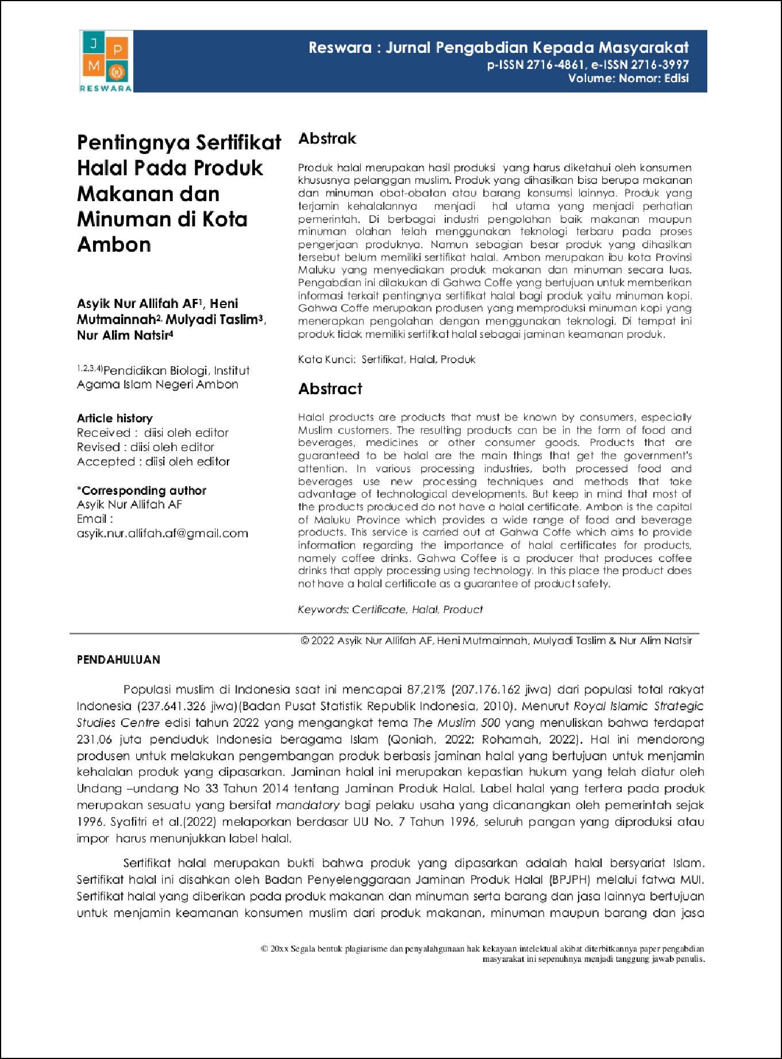
1

4

8

8

9

2

2
2
7
2

4

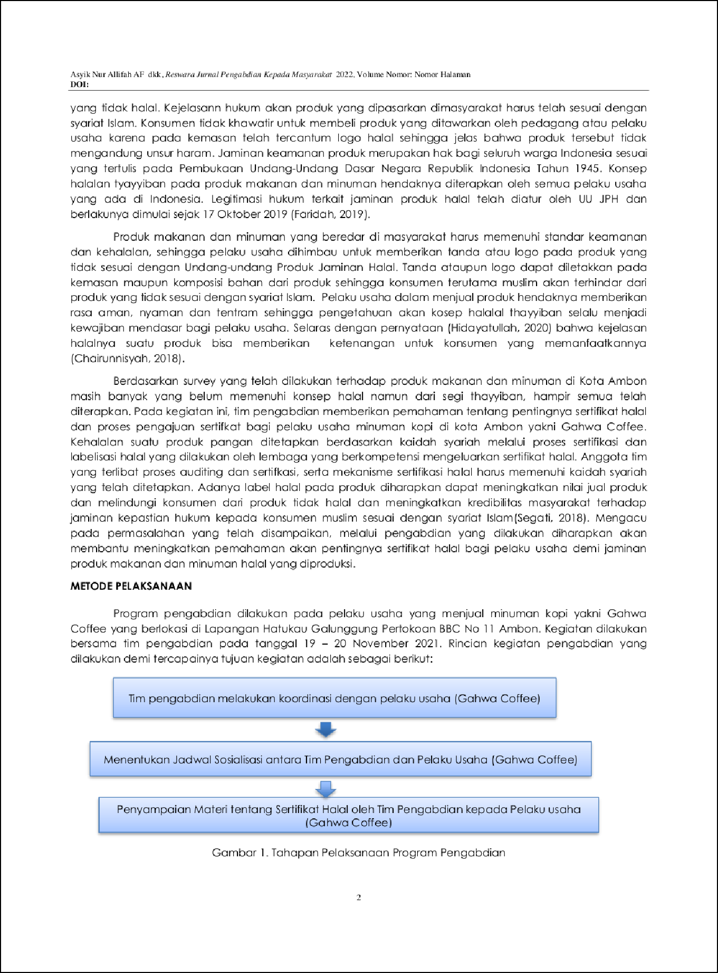

1

11

7

1

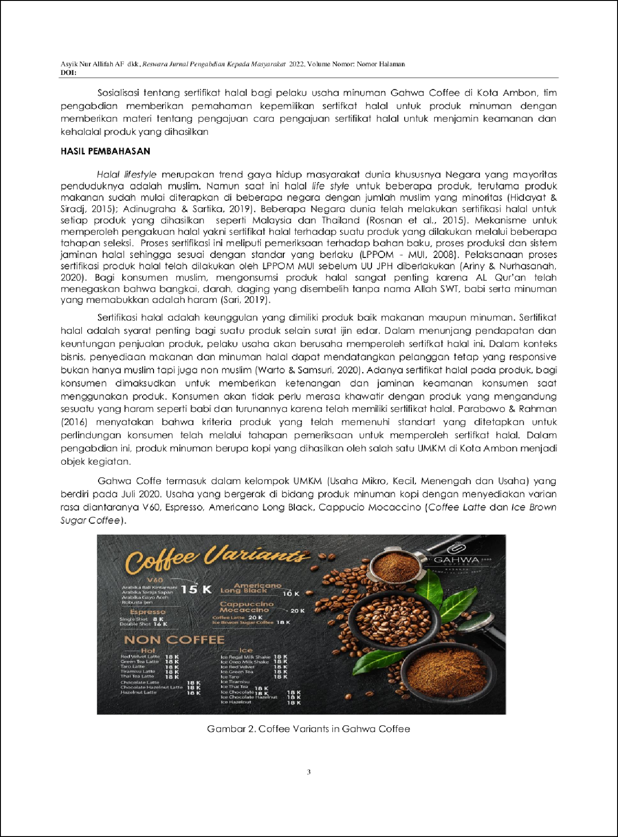

1

2

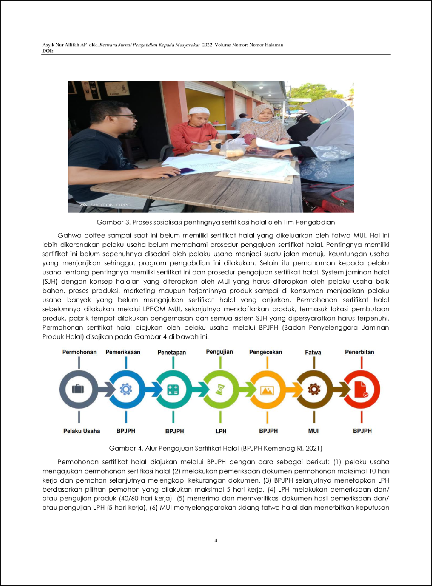

1

2

2

6
3

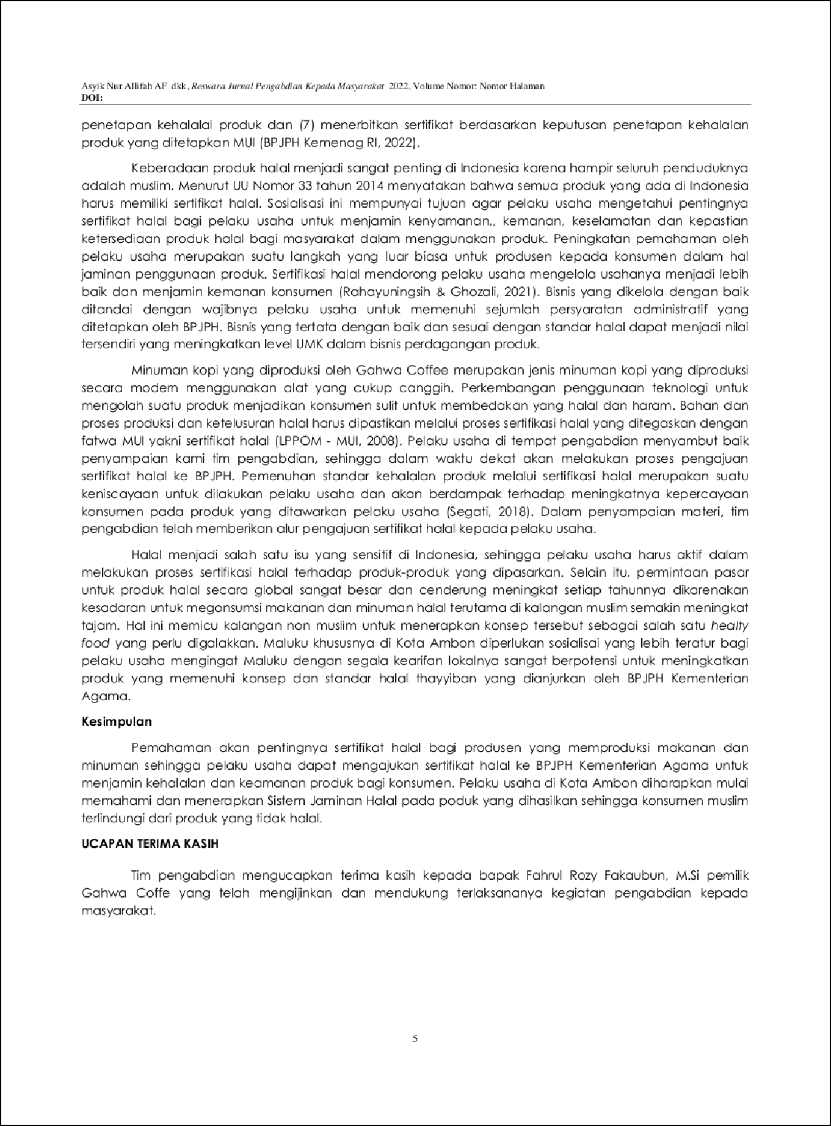

1

5

10



1-JURNAL_RESWARA_PUBLISH_2022_REVISI_-_Copy.docx
13
ORIGINALITY REPORT

%
SIMILARITY INDEX
13%
INTERNET SOURCES
8%
PUBLICATIONS
8%
STUDENT PAPERS

PRIMARY SOURCES
Submitted to Academic Library Consortium
Student Paper %
1
3
2

repository.uinsu.ac.id
Internet Source %
2
2

www.idxchannel.com
Internet Source %
3
2

jurnal.dharmawangsa.ac.id
Internet Source %
4
1%

5 Uswatun Hasanah. "ANALISIS PELUANG DAN TANTANGAN INDUSTRI HALAL PADA MASA PANDEMI COVID 19 DI INDONESIA", JOURNAL ECONOMICS AND STRATEGY, 2021
Publication
1

fesyarjawa.com
Internet Source %
6
1

media.neliti.com
Internet Source %
7
1%

8 Abdul Syatar Syatar, Firdayanti Firdayanti. "THE AUTHORITY OF THE INDONESIAN

9

10

11
ULAMA COUNCIL IN CERTIFYING HALAL
PRODUCTSThe Authority of the Indonesian Ulama Council in Certifying Halal Products From a Siyasah Syar’iyyah Perspective", INTERNATIONAL JOURNAL OF CONTEMPORARY ISLAMIC LAW AND SOCIETY, 2022
Publication

digilib.uinsby.ac.id
1
Internet Source %

docplayer.info
1
Internet Source %

text-id.123dok.com
1
Internet Source %

Exclude quotes On Exclude bibliography On
Exclude matches < 1%

