CORRELATIONS
/VARIABLES=PK.1 PK.2 PK.3 PK.4 SUMPK
/PRINT=TWOTAIL NOSIG
/MISSING=PAIRWISE.

Correlations Y

Correlations
 |  | PK.1 | PK.2 | PK.3 | PK.4 | SUMPK
PK.1 | Pearson Correlation | 1 | ,697** | ,658** | ,516** | ,896**
PK.1 | Sig. (2-tailed) |  | ,000 | ,000 | ,000 | ,000
PK.1 | N | 132 | 132 | 132 | 132 | 132
PK.2 | Pearson Correlation | ,697** | 1 | ,288** | ,415** | ,723**
PK.2 | Sig. (2-tailed) | ,000 |  | ,001 | ,000 | ,000
PK.2 | N | 132 | 132 | 132 | 132 | 132
PK.3 | Pearson Correlation | ,658** | ,288** | 1 | ,523** | ,799**
PK.3 | Sig. (2-tailed) | ,000 | ,001 |  | ,000 | ,000
PK.3 | N | 132 | 132 | 132 | 132 | 132
PK.4 | Pearson Correlation | ,516** | ,415** | ,523** | 1 | ,772**
PK.4 | Sig. (2-tailed) | ,000 | ,000 | ,000 |  | ,000
PK.4 | N | 132 | 132 | 132 | 132 | 132
SUMPK | Pearson Correlation | ,896** | ,723** | ,799** | ,772** | 1
SUMPK | Sig. (2-tailed) | ,000 | ,000 | ,000 | ,000
SUMPK | N | 132 | 132 | 132 | 132 | 132

**. Correlation is significant at the 0.01 level (2-tailed).

RELIABILITY
/VARIABLES=PK.1 PK.2 PK.3 PK.4
/SCALE('ALL VARIABLES') ALL
/MODEL=ALPHA.

Reliability Y

Reliability Statistics
Cronbach's Alpha | N of Items
,809 | 4

Correlations X1

Correlations
 |  | PI.1 | PI.2 | PI.3 | PI.4 | PI.5 | SUMPI
PI.1 | Pearson Correlation | 1 | ,657** | ,548** | ,515** | ,536** | ,792**
PI.1 | Sig. (2-tailed) |  | ,000 | ,000 | ,000 | ,000 | ,000
PI.1 | N | 132 | 132 | 132 | 132 | 132 | 132
PI.2 | Pearson Correlation | ,657** | 1 | ,724** | ,509** | ,482** | ,814**
PI.2 | Sig. (2-tailed) | ,000 |  | ,000 | ,000 | ,000 | ,000
PI.2 | N | 132 | 132 | 132 | 132 | 132 | 132
PI.3 | Pearson Correlation | ,548** | ,724** | 1 | ,483** | ,574** | ,802**
PI.3 | Sig. (2-tailed) | ,000 | ,000 |  | ,000 | ,000 | ,000
PI.3 | N | 132 | 132 | 132 | 132 | 132 | 132
PI.4 | Pearson Correlation | ,515** | ,509** | ,483** | 1 | ,748** | ,814**
PI.4 | Sig. (2-tailed) | ,000 | ,000 | ,000 |  | ,000 | ,000
PI.4 | N | 132 | 132 | 132 | 132 | 132 | 132
PI.5 | Pearson Correlation | ,536** | ,482** | ,574** | ,748** | 1 | ,842**
PI.5 | Sig. (2-tailed) | ,000 | ,000 | ,000 | ,000 |  | ,000
PI.5 | N | 132 | 132 | 132 | 132 | 132 | 132
SUMPI | Pearson Correlation | ,792** | ,814** | ,802** | ,814** | ,842** | 1
SUMPI | Sig. (2-tailed) | ,000 | ,000 | ,000 | ,000 | ,000
SUMPI | N | 132 | 132 | 132 | 132 | 132 | 132

**. Correlation is significant at the 0.01 level (2-tailed).

RELIABILITY
/VARIABLES=PI.1 PI.2 PI.3 PI.4 PI.5
/SCALE('ALL VARIABLES') ALL
/MODEL=ALPHA.

Reliability X1

Reliability Statistics
Cronbach's Alpha | N of Items
,869 | 5

Correlations X2

Correlations
 |  | WS.1 | WS.2 | WS.3 | WS.4 | SUMWS
WS.1 | Pearson Correlation | 1 | ,582** | ,395** | ,315** | ,778**
WS.1 | Sig. (2-tailed) |  | ,000 | ,000 | ,000 | ,000
WS.1 | N | 132 | 132 | 132 | 132 | 132
WS.2 | Pearson Correlation | ,582** | 1 | ,589** | ,335** | ,819**
WS.2 | Sig. (2-tailed) | ,000 |  | ,000 | ,000 | ,000
WS.2 | N | 132 | 132 | 132 | 132 | 132
WS.3 | Pearson Correlation | ,395** | ,589** | 1 | ,513** | ,813**
WS.3 | Sig. (2-tailed) | ,000 | ,000 |  | ,000 | ,000
WS.3 | N | 132 | 132 | 132 | 132 | 132
WS.4 | Pearson Correlation | ,315** | ,335** | ,513** | 1 | ,657**
WS.4 | Sig. (2-tailed) | ,000 | ,000 | ,000 |  | ,000
WS.4 | N | 132 | 132 | 132 | 132 | 132
SUMWS | Pearson Correlation | ,778** | ,819** | ,813** | ,657** | 1
SUMWS | Sig. (2-tailed) | ,000 | ,000 | ,000 | ,000
SUMWS | N | 132 | 132 | 132 | 132 | 132

**. Correlation is significant at the 0.01 level (2-tailed).

RELIABILITY
/VARIABLES=WS.1 WS.2 WS.3 WS.4
/SCALE('ALL VARIABLES') ALL
/MODEL=ALPHA.

Reliability X2

Reliability Statistics
Cronbach's Alpha | N of Items
,764 | 4

NORMALITAS

One-Sample Kolmogorov-Smirnov Test
 |  | Unstandardized Residual
N |  | 132
Normal Parameters^{a,b} | Mean | ,0000000
Normal Parameters^{a,b} | Std. Deviation | ,53331920
Most Extreme Differences | Absolute | ,098
Most Extreme Differences | Positive | ,071
Most Extreme Differences | Negative | -,098
Test Statistic |  | ,098
Asymp. Sig. (2-tailed) |  | ,073^{c}

a. Test distribution is Normal.
b. Calculated from data.
c. Lilliefors Significance Correction.

MULTIKOLINIERITAS

 |  |  | Coefficientsª
Model |  | Unstandardized Coefficients |  |  | Standardized Coefficients | t | Sig. | Collinearity Statistics
 |  | B |  | Std. Error | Beta | t | Sig. | Tolerance | VIF
1 | (Constant) | ,792 |  | ,245 |  | 3,239 | ,002
1 | KPK | ,498 |  | ,064 | ,550 | 7,764 | ,000 | ,734 | 1,363
1 | KPRJ | ,261 |  | ,069 | ,267 | 3,767 | ,000 | ,734 | 1,363

a. Dependent Variable: KUP

HETEROSKIDASITAS

Charts

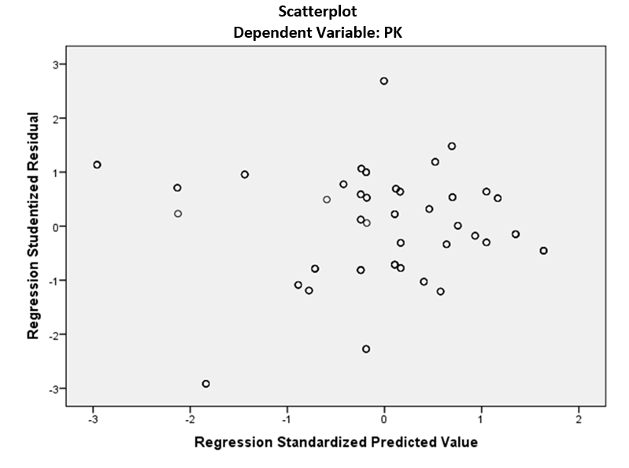

AUTOKOLERASI
Model Summary^{b}
Model | R | R Square | Adjusted R Square | Std. Error of the Estimate | Durbin-Watson
1 | ,725ª | ,525 | ,518 | ,53744 | 1,656

a. Predictors: (Constant), WS, PI
b. Dependent Variable: PK

REGRESI

Model Summary
Model | R | R Square | Adjusted R Square | Std. Error of the Estimate
1 | ,725ª | ,525 | ,518 | ,53744

a. Predictors: (Constant), PI, PI

ANOVAª
Model |  | Sum of Squares | df | Mean Square | F | Sig.
1 | Regression | 41,181 | 2 | 20,591 | 71,287 | ,000^{b}
1 | Residual | 37,260 | 129 | ,289
1 | Total | 78,441 | 131

a. Dependent Variable: PK
b. Predictors: (Constant), WS, PI

Coefficientsª
Model |  | Unstandardized Coefficients |  | Standardized Coefficients | t | Sig.
 |  | B | Std. Error | Beta | t | Sig.
1 | (Constant) | ,792 | ,245 |  | 3,239 | ,002
1 | PI | ,498 | ,064 | ,550 | 7,764 | ,000
1 | WS | ,261 | ,069 | ,267 | 3,767 | ,000

a. Dependent Variable: PK

