 Translated from Indonesian to English - www.onlinedoctranslator.com
THE IMPACT OF THE CONTRIBUTION OF THE MINING AND QUARRYING SECTOR AND THE PROCESSING INDUSTRY ON ECONOMIC GROWTH IN BENGKALIS REGENCY 2011-2024

Della Novita Sari1 Melani ¹Noviantori Ramadhan², Farraz Yuni Syafitri³, Wiwi Jupiani⁴
University of Riau1234
della.novita1061@student.unri.ac.id

ABSTRACT

This study aims to analyze the influence of the mining and quarrying sector and the manufacturing industry sector on economic growth in Bengkalis Regency for the period 2011–2024. Economic growth is measured using Gross Regional Domestic Product (GRDP) at constant prices which describes the real economic performance of the region. This study uses a quantitative method with a descriptive approach and multiple linear regression analysis, based on secondary data obtained from the Central Statistics Agency (BPS) of Bengkalis Regency. The results of the analysis show that partially, the mining and quarrying sector has a significant effect on economic growth with a significance value of 0.000 < 0.05. Conversely, the manufacturing industry sector does not have a significant effect with a significance value of 0.539 > 0.05. Simultaneously, both sectors have a significant effect on economic growth with a significance value of 0.000 < 0.05 and an Adjusted R² value of 0.926, which means that 92.6% of the variation in economic growth can be explained by these two sectors. These findings indicate that the economy of Bengkalis Regency is still dominated by mining and quarrying sector activities, while the manufacturing industry sector has not provided an optimal contribution to regional economic growth. Therefore, a strategy is needed to strengthen the processing industry sector through investment, technological innovation, and downstream development so that the regional economic structure becomes more balanced and sustainable.

Keywords: mining and quarrying sector, manufacturing industry, economic growth, GRDP, Bengkalis

INTRODUCTION
Bengkalis Regency is a region in Riau Province known for its abundant natural resources. Its strategic geographic location along the Strait of Malacca makes it not only a potential hub for trade development but also rich in mining and other natural resources. This makes Bengkalis one of the driving forces of the economy on the east coast of Sumatra.
The mining and quarrying sector is one of the leading sectors in Bengkalis Regency. The presence of oil and natural gas resources, for example, has long been the backbone of the regional economy. This sector contributes significantly to the region's Gross Regional Domestic Product (GRDP) and is a major source of regional revenue. With this potential, the local government has a significant opportunity to promote more equitable and sustainable economic development.
In addition to the mining sector, the manufacturing industry is also developing as a downstream form of natural resource utilization. The processing industry for oil, gas, and other natural product-based products plays a role in increasing the added value of Bengkalis' primary commodities. This sector is expected to create new jobs, investment opportunities, and improve the regional economic structure, eliminating the need for a reliance solely on raw resources.
Theoretically, these two sectors should make a positive contribution to improving public welfare. Economic growth generated by mining and the manufacturing industry is expected to increase community incomes, expand employment opportunities, and accelerate regional infrastructure development. Thus, the presence of leading sectors not only improves macroeconomic statistics but also has a direct impact on people's daily lives.
However, the reality on the ground does not always align with these expectations. A development paradox often occurs, where resource-rich regions fail to fully improve the well-being of their communities. High macroeconomic growth does not automatically guarantee increased prosperity. The majority of the profits are enjoyed by large corporations or the central government, while local communities face limited access to directly benefit from them.
In Bengkalis Regency, socio-economic issues persist, stemming from the growth of the mining and manufacturing sectors. Issues such as unemployment, income inequality, and low quality education and healthcare remain significant challenges. Furthermore, environmental damage caused by the exploitation of natural resources also impacts the livelihoods of the community, particularly those whose livelihoods depend on the fisheries and agriculture sectors.
This raises a major question about the extent to which the mining, quarrying, and manufacturing sectors truly influence economic growth in Bengkalis Regency. Is the growth of these two sectors directly felt by the community through improved living standards, or is it merely a mere speck of paper in regional economic reports? This question provides an important basis for further in-depth research.
The period 2011–2024 was chosen as the focus of this research because it encompasses various important dynamics in regional development. During this period, both regional and central governments implemented numerous development acceleration programs, including industrial downstreaming and optimizing natural resource utilization. Furthermore, this period also witnessed external dynamics, such as fluctuations in global oil prices, the COVID-19 pandemic disrupting economic activity, and the global energy transition trend impacting the oil and gas sector. All of these factors can influence the contribution of these two leading sectors to public welfare.
The urgency of this research becomes even clearer when viewed from the perspective of the local government's responsibilities. As a natural resource-producing region, Bengkalis has an obligation to ensure that its natural resources not only generate superficial economic growth but also genuinely improve the quality of life for its residents. The local government needs an empirical understanding of the relationship between growth in the mining and processing sectors and community well-being to formulate more targeted policies.
Thus, research into the influence of the mining, quarrying, and manufacturing sectors on the well-being of the Bengkalis Regency community is highly relevant. The results are expected to address concerns about the actual contribution of these two sectors and provide input for more inclusive regional development planning. Through this analysis, the local government is expected to be able to develop development strategies that not only pursue economic growth but also ensure the realization of equitable and sustainable community well-being.
The aim of this study is to analyze the development of the mining and quarrying sector and the processing industry sector in Bengkalis Regency in 2011–2024.
- To determine the influence of the mining and quarrying sector on Economic Growth in Bengkalis Regency 2011-2025.
- To determine the influence of the processing industry sector on Economic Growth in Bengkalis Regency 2011-2025.

LITERATURE REVIEW
- The Concept of Economic Growth
Economic growth is a condition of a region that reflects sustainable economic changes over a certain period of time towards achieving a better situation. This improvement in economic conditions is a benchmark for a country's success at the international, national, and regional levels, with the primary goal of improving public welfare. The success of a region's economic growth can be measured through the Gross Regional Domestic Product (GRDP). The GRDP value is used to measure regional income and is divided into two categories: GRDP at constant prices and current prices. GRDP at constant prices reflects real economic growth each year, so price changes are not affected. Meanwhile, GRDP at current prices is used to assess the strength of the economic structure, shifts, and potential economic resources of the region.
Economic growth reflects a country's economic condition, measured by a faster increase in total income, resulting in increased per capita income and a more prosperous standard of living. Regional income is measured using Gross Regional Domestic Product (GRDP) data. GRDP can be calculated using three approaches: the expenditure approach, the income approach, and the production approach. The expenditure approach calculates GRDP based on the accumulation of various expenditures made by economic actors. The income approach calculates GRDP by summing all income factors obtained from production activities, such as profits, investments, wages, and rent. The production approach, on the other hand, takes into account the total production output from various economic sectors. The GRDP value in a region provides a general overview of the level of community welfare and the level of economic growth in that region. An increase in GRDP indicates higher economic growth and improved community welfare in that region.(Pratiwi et al., 2023).
The economy in Bengkalis Regency is faced with economic growth from year to year as indicated by the Gross Regional Domestic Product (GRDP) figures. The magnitude of economic growth should be a flexibility that can be used optimally in encouraging the regional economy to return to normal. The economic growth owned by which is supported by 17 sectors, namely: Social Activities and Health Services; Education Services; Mandatory Social Security, Defense, and Government Administration; Corporate Services; Real Estate; Insurance and Financial Services; Communication and Information; Food and Beverage Provision and Accommodation; Warehousing and Transportation; Motorcycle and Car Repair; Retail and Wholesale Trade; Construction; Waste Management, Recycling and Waste; Water Supply; Gas and Electricity Supply; Processing Industry; Quarrying and Mining; Fisheries, Forestry and Agriculture; and other Services. Based on data from the Bengkalis Regency Statistics Agency (BPS), the contribution regarding the amount of production results from several sectors is the most important, namely Mining and Quarrying, but it cannot be denied that other sectors also contribute to the economy, including the processing industry sector. The impressive performance of economic sectors has returned GDP to a positive level. (Central Statistics Agency (BPS), 2024)
- Mining and Excavation Sector Concept
Businesses in the Mining and Quarrying sector essentially aim to obtain various types of mining products, minerals, and excavated materials, whether solid, liquid, or gaseous, found within or on the earth's surface. The use of these mining products and excavated materials aims to create added value, allowing them to be further utilized, sold to others, or exported.
Based on Law Number 4 of 2009 concerning Mineral and Coal Mining, Article 1 paragraph (1), mining includes some or all stages of activities including research, management, and exploitation of minerals or coal. The mining and quarrying sector remains a key pillar of Indonesia in supporting economic growth and employment. This is reflected in the high level of investment interest in this sector, driven by Indonesia's abundance of natural resources, such as coal.
- The Concept of the Manufacturing Industry Sector
The processing industry is an economic activity focused on transforming raw or semi-finished materials into higher-value products. This process can be carried out through physical, chemical, or biological mechanisms, with the aim of producing products with different functions, forms, and qualities than the original materials. The processing industry plays a crucial role as a link between primary sectors, such as agriculture, plantations, and mining, and downstream sectors that produce ready-to-consume products and advanced raw materials for other industries. In addition to increasing the added value of natural resources, the processing industry also contributes to job creation, increased exports, and stimulated regional and national economic growth, making it a strategic sector in economic development.
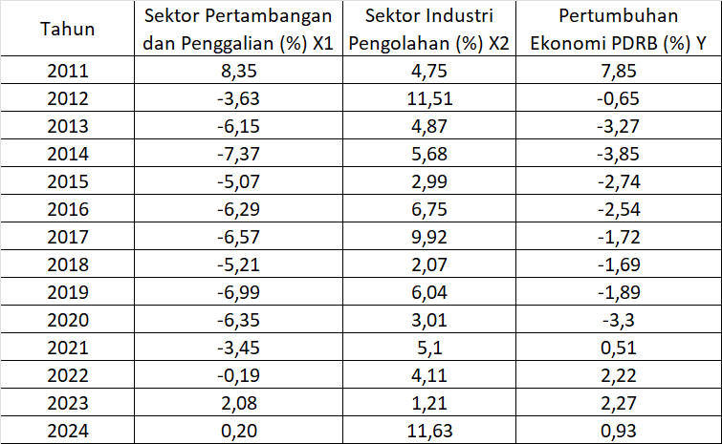

Table 1. Data on the Mining and Quarrying Sector, as well as the Manufacturing Industry Sector, and GRDP of Bengkalis Regency 2011-2024

The mining and quarrying sector's value fluctuated and tended to be negative throughout the observation period. 2011 recorded the highest growth of 8.35%, but from 2012 to 2020, this sector was dominated by negative growth, even reaching its lowest point in 2014 (-7.37%) and 2019 (-6.99%). This indicates that the mining sector experienced a sharp decline in productivity and performance, possibly due to: Declining global mining commodity prices (such as coal and oil), Limited raw material exports due to downstreaming policies, and high dependence on global demand. From 2022 to 2024, this sector began to stabilize with growth approaching 0% to slightly positive (0.20%), indicating signs of recovery after nearly a decade of pressure.
The manufacturing sector has shown a positive and relatively stable growth trend compared to the mining sector. The highest growth was recorded in 2012 at 11.51% and in 2024 at 11.63%. However, this sector experienced a significant slowdown in 2018 at 2.07% and 2020 at 3.01%, thought to be the impact of the COVID-19 pandemic. Overall, the manufacturing sector plays a crucial role as a driving force for the national economy, reflecting the success of the downstreaming process and the increased added value of domestic products.
Research requires information relevant to the problem being studied. Therefore, previous research is needed to gather information, conduct comparative analysis, and discover new ideas that can inspire subsequent research. Below are some journal articles from previous research.
First,previous research with the title "The Influence of the Mining and Excavation Sector on the Gross Regional Domestic Product of Banggai Regency" written by(Barri, Zakaria and Bidullah, 2021)has the aim to determine the influence of mining and desire on the Gross Regional Domestic Product (GRDP) of Banggai Regency. This study aims to analyze the relationship and contribution of mining to economic growth in the Banggai Regency area. The results of this study show a regression equation, namely Y = 7927045.556 + 2.128 X, in the equation it can be seen that the value of X is 2.128 (positive), this means that if the mining and quarrying sector increases, the GRDP of Banggai Regency will also increase and if the mining and quarrying sector is equal to zero (0) then the GRDP of Banggai Regency will experience a decrease of 7927045.556. The magnitude of the correlation coefficient (R) obtained is 0.991, this means that the relationship between the mining and quarrying sector and GRDP is very strong because it is in the interval of 0.80-1,000. Based on the results of the t-test, the t-value obtained is t-test > t-table or 14.494 > 2.776, meaning that the mining and excavation sector has a positive and significant effect on the Gross Regional Domestic Product (GRDP) of Banggai Regency.
Second, (Noor, 2019)in his research entitled "The Role of the Mining and Quarrying Sector in the Economy of East Kalimantan" aims to analyze the contribution of the mining and quarrying sector to the Gross Regional Domestic Product (GRDP) and labor absorption in East Kalimantan. This research uses a quantitative descriptive method with secondary data from BPS Indonesia and BPS East Kalimantan for the period 2010–2016 which is analyzed through the Location Quotient (LQ), Multiplier Effect, Labor Elasticity, and Linear Trend Analysis approaches. The results of the study show that although the mining and quarrying sector is still a basic sector with an LQ value > 1 and a trend that tends to increase, its contribution to GRDP has decreased and labor absorption is very low due to its capital intensive nature. The multiplier effect analysis also shows that the dominance of mining does not have a significant positive impact on regional development, even tends to cause inequality and weaken the balance of the regional economic structure.
Third,(Faisal, Nugraha and Aminudin, 2023)In his article entitled "Analysis of the Role of the Agricultural and Industrial Sectors on Community Welfare Through the Economic Growth of GRDP in Banten Province," this study highlights the relationship between the agricultural and industrial sectors on economic growth and community welfare. Several previous studies have shown that the agricultural sector in certain regions can support industrial development and import-export, but high dependence on global markets and low investment limit economic growth. In addition, the quality of employment in these regions remains low, with many temporary and unskilled workers, which leads to high unemployment and poverty rates. In general, previous research indicates that the direct influence of the agricultural and industrial sectors on community welfare is not yet significant enough, although both can contribute indirectly through economic growth. These results indicate the need for the development of leading sectors and supporting policies so that these sectors can improve welfare more effectively.

- RESEARCH METHODS
The scope of this research is the mining and processing industry sectors in Bengkalis Regency. Community welfare is measured by the Human Development Index (HDI). This study uses data from the Bengkalis Regency Statistics Agency (BPS) from 2011 to 2024. This research was conducted using a quantitative method with a descriptive approach. The descriptive method is a research method that conveys facts by describing what is seen, obtained, and felt (Purba et al., 2021). Data in quantitative research is in numerical form.
This study uses numbers as a tool for analyzing the research question. The data collection technique involves collecting secondary data obtained from other parties in the form of publications. Secondary data was collected from the Statistics Indonesia (BPS) and related institutions from 2011 to 2024 in Bengkalis Regency.
The data analysis method used in this study is multiple linear regression analysis using time series data. The multiple linear regression model used in this study is as follows:

Y= a + b1X1 + b2X2 + e
Information
Y = GRDP
a = Constant
b1, b2 = Regression Number
X1 = Mining Excavation Sector
X2 = Manufacturing Industry Sector
e = Standard Error
.

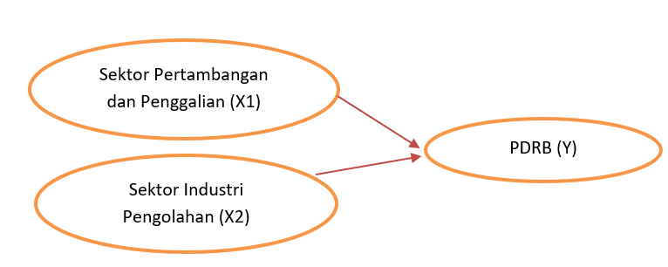

Figure 1 Conceptual Framework of the Research

- RESULTS AND DISCUSSION
Classical Assumption Test Results
- Normality Test using Kolmogorov-Smirnov
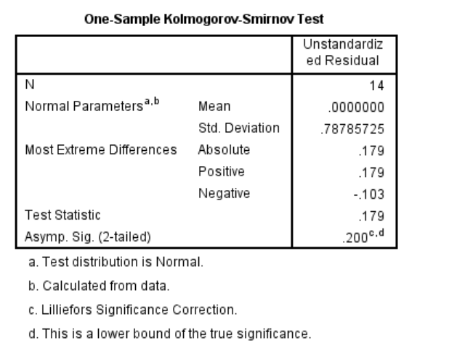

Figure 2 Results of Normality Test using Kolmogorov-Smirnov

The normality test aims to determine whether the residual data in a regression model is normally distributed or not. Residual normality is an important assumption in classical linear regression analysis, because a good regression model must have residuals that are normally distributed. One method commonly used to test data normality is the Kolmogorov-Smirnov (KS) test. This test compares the cumulative distribution of the tested data with the theoretical normal distribution. The provisions of the Kolmogorov-Smirnov test are that if the significance value (Asymp. Sig. 2-tailed) is greater than the significance level α = 0.05, then the data is considered normally distributed; conversely, if the significance value is less than 0.05, then the data is not normally distributed.
Based on the figure above, the Asymp. Sig. (2-tailed) value is 0.200, which is greater than 0.05. Thus, it can be concluded that the residual data in this study is normally distributed. This result indicates that the normality assumption is met, so the regression model used is suitable for further testing, such as heteroscedasticity, autocorrelation, and hypothesis testing.

- Multicollinearity Test
A multicollinearity test is performed to determine whether there is a strong relationship between the independent variables in a regression model. The purpose of this test is to ensure that each independent variable provides unique information about the dependent variable and is not highly correlated with each other. The criteria for a multicollinearity test can be seen from the Tolerance and Variance Inflation Factor (VIF) values. A model is considered free of multicollinearity if the Tolerance value is >0.10 and the VIF is <10.
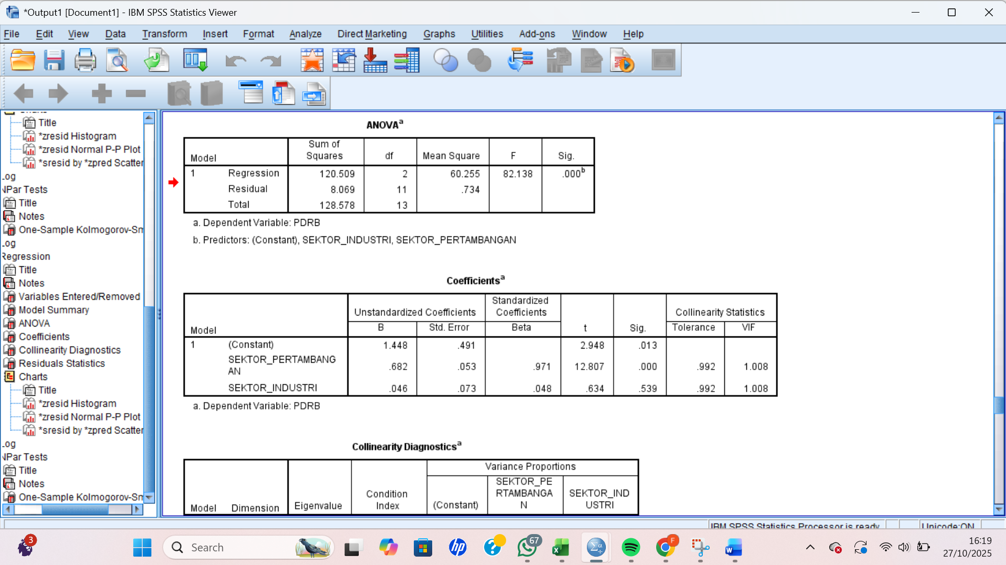

Figure 3 Multicollinearity Test Results

Based on the results of the multicollinearity test in the table above, it is known that the Tolerance value for the Mining Sector and Industrial Sector variables is 0.992, respectively, and the VIF value is 1.008. Because the Tolerance value is greater than 0.10 and the VIF value is less than 10, thus, it can be said that there is no very strong correlation between each independent variable or in other words, there is no multicollinearity.

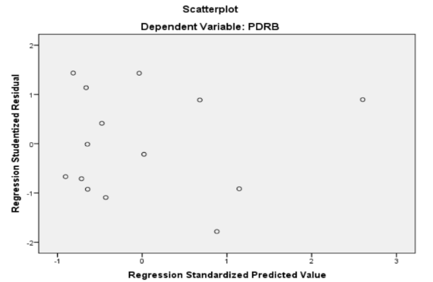
- Heteroscedasticity Test using Scatterplot

Figure 4 Heteroscedasticity Test Results

The heteroscedasticity test aims to determine whether or not there is inequality in residual variance between observations in a regression model. The rule is, if the points on the scatterplot graph are randomly distributed above and below the horizontal axis without forming a specific pattern, then it can be concluded that heteroscedasticity does not occur. Based on the scatterplot graph in this study, it can be seen that the points are randomly distributed and do not form a clear pattern, so it can be concluded that the regression model is free from symptoms of heteroscedasticity.

Multiple Linear Regression Results
The results of multiple linear regression were carried out to evaluate quantitatively the influence of the mining and quarrying sector and the processing industry sector on economic growth in Bengkalis Regency.

- Coefficient of Determination

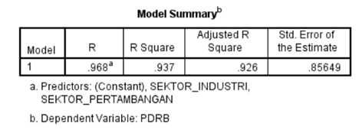
Figure 5 Coefficient of Determination

The coefficient of determination measures the ability of independent variables to collectively explain the dependent variable. The higher the value, the better the regression model is at explaining the data. The test results are as follows:
- The R value is 0.968. This indicates a very strong relationship between the independent variables (Industrial Sector and Mining Sector) and the dependent variable (GRDP). The value of 0.968 is close to 1, indicating a very close relationship between the two.
- The R Square value is 0.937, or 93.7%, indicating that 93.7% of the variation or change in GRDP can be explained by the Industrial and Mining Sector variables. The remaining 6.3% is influenced by other variables outside the two sectors in this research model.
- Adjusted R Square = 0.926. This indicates a value adjusted for the number of independent variables. This value is still high, indicating that the model used is stable and appropriate to the research data.
- Standard Error of the Estimate = 0.85649, which indicates the magnitude of the standard error of the prediction in the regression model. In other words, this value illustrates how far the predicted GRDP value by the regression model (which is based on the industrial and mining sectors) deviates from the actual GRDP value.
The coefficient of determination in this study indicates that the Mining and Quarrying Sector and the Manufacturing Industry Sector have a significant influence on economic growth. With a contribution of 93.7%, the regression model used is highly appropriate for explaining the relationship between variables. Only a small portion (6.3%) of the variation in economic growth is influenced by factors outside this research model.
- F Test (Simultaneous)
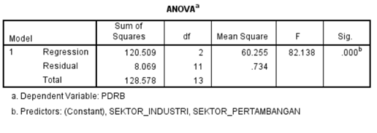

Figure 6 F Test Results (Simultaneous)
Based on the ANOVA table, the results obtained are:
- F count = 82.138
- Significance (Sig) = 0.000
- Df regression = 2, df residual = 11, and df total = 13
Decision making criteria:
- If the Sig. value is < 0.05, then the simultaneous regression model is significant.
- If the Sig. value > 0.05, then the simultaneous regression model is not significant.
The test results show that the Sig value is 0.000 < 0.05, so it can be concluded that the independent variables, namely the mining and quarrying sector and the processing industry sector together (simultaneously), have a significant effect on the dependent variable, namely economic growth as measured by GRDP.
With a large F-value (82.138) and a very small significance level (0.000), the regression model used proved to be highly significant simultaneously. This means that the two sectors, when tested together, were able to explain changes in the Human Development Index strongly and significantly.

- Partial T-Test

Figure 7 Partial T-Test Results

From the image above, namely:
- Mining and Quarrying Sector
- The value of t = 12.807
- Sig. Value = 0.000 < 0.05
This means its influence is statistically significant on economic growth. The more the mining and quarrying sector develops, the greater its contribution to economic growth in Bengkalis Regency.
- Manufacturing Industry Sector
- T value = 0.634
- Sig. Value = 0.539 < 0.05
This means the effect is not statistically significant. The Manufacturing Industry sector has a positive but insignificant effect on GRDP in this research model. Although the coefficient is positive, its effect is not strong enough to partially influence GRDP.

Partially, the mining and quarrying sector significantly influences economic growth, as it creates more added value, creates jobs, and drives economic growth, which directly impacts the community's quality of life. Conversely, the manufacturing sector does not significantly influence economic growth. This may be due to mining activities being more focused on exploiting natural resources, which does not always directly impact the community's welfare or quality of life.

The Influence of the Mining and Quarrying Sector on Economic Growth in Bengkalis Regency 2011-2024
Based on the results of the partial t-test on the variable contribution of the mining and quarrying sector to the economic growth of Bengkalis Regency for the period 2011–2024, a significance value of 0.000 was obtained. The t-test provisions state that if the significance value is smaller than the significance level α = 0.05, then the independent variable has a significant influence on the dependent variable. Conversely, if the significance value is greater than 0.05, then the variable is declared to have no significant influence.

The results indicate that the significance value (0.000) < α (0.05), thus it can be concluded that the contribution of the mining and quarrying sector is more dominant and has a significant influence on economic growth in Bengkalis Regency. This means that the increase in contribution from the mining and quarrying sector was significantly able to drive regional economic growth during the research period.

The Influence of the Manufacturing Industry Sector on Economic Growth in Bengkalis Regency 2011-2024
Based on the results of the partial t-test on the manufacturing industry sector variable on the economic growth of Bengkalis Regency for the 2011–2024 period, a significance value of 0.539 was obtained. In accordance with the provisions of the t-test, if the significance value is smaller than the significance level α = 0.05, then the independent variable has a significant effect on the dependent variable. Conversely, if the significance value is greater than 0.05, then the variable does not have a significant effect on economic growth.

The results of the study indicate that the significance value (0.539) > α (0.05), so it can be concluded that the manufacturing industry sector does not have a significant effect on economic growth in Bengkalis Regency. When compared to the mining and quarrying sector which has a significance value of 0.000 < 0.05, the mining and quarrying sector has a much stronger and more significant influence on regional economic growth. This indicates that the economy of Bengkalis Regency during the study period was still supported more by activities in the mining and quarrying sector than the manufacturing industry sector.

The Influence of the Mining and Excavation Sector and the Manufacturing Industry Sector on Economic Growth in Bengkalis Regency in 2011-2024

Based on the results of the simultaneous test (F test) on the mining and quarrying sector variables and the processing industry sector on the economic growth of Bengkalis Regency for the period 2011–2024, a significance value of 0.000 was obtained. The F test provisions state that if the significance value is smaller than the significance level α = 0.05, then the independent variables together have a significant effect on the dependent variable. Conversely, if the significance value is greater than 0.05, then there is no significant simultaneous effect.

The results of the study show that the significance value (0.000) < α (0.05), so it can be concluded that the mining and quarrying sector and the processing industry sector simultaneously have a significant effect on economic growth in Bengkalis Regency. The Adjusted R Square value of 0.926 indicates that the two sectors are able to explain 92.6% of the variation in changes in economic growth, while the remaining 7.4% is influenced by other factors outside the research model. This shows that the combined contribution of the two sectors has a very strong role in determining the economic growth of Bengkalis Regency during the 2011–2024 period.

IV.CONCLUSION
This study aims to analyze the influence of the mining and quarrying sector and the manufacturing industry sector on economic growth in Bengkalis Regency for the period 2011–2024. Based on the results of multiple linear regression analysis and a series of classical assumption tests, the regression model was declared suitable for use because it met the assumptions of normality, was free from multicollinearity, and did not experience heteroscedasticity. This indicates that the research model has good validity for measuring the relationship between variables.
Partially, the t-test results indicate that the mining and quarrying sector variable has a significance value of 0.000, which is smaller than the significance level of α = 0.05. This means that the mining and quarrying sector has a significant influence on the economic growth of Bengkalis Regency. This finding indicates that the increasing contribution from the mining and quarrying sector has a positive impact on the rate of regional economic growth. Exploration and production activities in this sector have proven to be one of the main drivers of economic dynamics in Bengkalis Regency during the study period.
Meanwhile, the partial test results for the manufacturing sector variable showed a significance value of 0.539, which is greater than α = 0.05. This indicates that the manufacturing sector does not significantly influence economic growth in Bengkalis Regency during the 2011–2024 period. This condition may be caused by the still low capacity of the manufacturing industry in the area or the less than optimal utilization of mining products and natural resources as raw materials for local industries. Thus, the manufacturing industry sector's contribution to economic growth is not as strong as the mining and quarrying sector.
Simultaneously, the F test results show a significance value of 0.000 < α (0.05), which means that the mining and quarrying sector and the processing industry sector together have a significant influence on economic growth in Bengkalis Regency. The Adjusted R Square value of 0.926 indicates that the two sectors are able to explain 92.6% of the variation in economic growth, while the remaining 7.4% is influenced by other factors outside the research model, such as the trade, service, or agricultural sectors. These results confirm that economic activity in the real sector, especially mining and quarrying, is the main supporter of regional economic growth during the research period.
Overall, this study concludes that Bengkalis Regency's economic growth remains heavily dependent on the mining and quarrying sector, while the manufacturing sector has not yet made a significant contribution. Therefore, strategic efforts are needed from the local government to strengthen the manufacturing sector through increased investment, infrastructure development, and increasing the added value of mining products. This way, Bengkalis Regency's economic structure can become more balanced and sustainable, and less dependent on the extractive sector alone.
Based on the research results, based on the results of the mining and quarrying sector test, the author recommends encouraging investment and technological innovation in mining activities to increase productivity. Improve environmental monitoring and sustainability so that mining activities remain environmentally friendly and sustainable. Optimize regional revenue from the mining subsector to support other economic development. Meanwhile, regarding the processing industry sector, although the industrial sector shows a positive, but not significant influence on GRDP, it is necessary to provide incentives for small and medium industry players (SMEs) to be able to develop and increase added value, encourage downstreaming of local resource-based industries to be more competitive, develop integrated industrial areas supported by adequate infrastructure, stable energy, and efficient logistics access. Because there is still 6.3% of the variation in GRDP explained by other factors outside the model, it is recommended that the government also pay attention to other sectors such as agriculture, tourism, trade, and services that can be additional pillars of economic growth.

REFRENCES
Barri, A., Zakaria, S. and Bidullah, T. (2021) 'The Influence of the Mining And Quarrying Sector on the Gross Regional Domestic Product of Banggai Regency', Productive Scientific Journal, 9(1), pp. 20–26.
Faisal, M., Nugraha, AT and Aminudin, I. (2023) 'Analysis of the Role of the Agricultural Sector and the Iindustrial Sector on Community Welfare Through the Economic Growth of GRDP n Banten Province', Paspalum: Agricultural Scientific Journal, 11(2), p. 197. Available at: https://doi.org/10.35138/paspalum.v11i2.569.
Noor (2019) 'The Role of the Mining and Quarrying Sector for the Economy of East Kalimantan', Inossa Research, 1, pp. 45–59.
Pratiwi, NJ et al. (2023) 'Analysis of the Contribution of the Manufacturing Industry Sector to the Economic Growth of West Sumatra Province', INNOVATIVE: Journal of Social Science Research Volume, Vol. 3(2), pp. 6722–6735.
Putra, S. et al. (2024) 'Processing Industry in North Sumatra Province', EQUILNOMI: Journal of Development Economics, 6(1), pp. 2614–7181.

_________________________

