 Translated from Indonesian to English - www.onlinedoctranslator.com
Analysis of Village Resilience Based on the 2024 Village Development Index in Bunga Raya Subdistrict

Hana Dalila Khonsa, Taryono, Asri Dwi Jovanka, Tasya Nofa, Nabila Cantika, Nazwa Azura Yasmin
Development Economics, Faculty of Economics and Business, University of Riau
hana.dallilah1082@student.unri.ac.id ¹,taryono@lecture.unri.ac.id,asri.jovanka1055@student.unri.ac.id ,tasya.nofa6595@student.unri.ac.id,nabila.cantika4966@student.unri.ac.id,nazwa.azura6584@student.unri.ac.id

ABSTRACT
This research aims to analyse the level of village resilience based on the 2024 Village Development Index (IDM) in Bunga Raya Subdistrict, Siak Regency, Riau Province. The three main dimensions examined include the Social Resilience Index (IKS), Economic Resilience Index (IKE), and Environmental Resilience Index (IKL), which reflect the ability of villages to provide basic services, strengthen economic independence, and maintain environmental sustainability. This study presents the latest empirical analysis using 2024 IDM data to assess multidimensional village resilience at the subdistrict level, which has rarely been done before. The results of this study enrich the study of rural development by identifying the balance between social, economic, and environmental dimensions in achieving the status of an Independent Village. This study uses a descriptive quantitative approach with secondary data from the 2024 IDM published by the Ministry of Villages, Disadvantaged Regions, and Transmigration of the Republic of Indonesia. All villages in Bunga Raya Sub-district have achieved ‘Independent Village’ status with an IDM value above 0.8; the highest being Bunga Raya Village (0.9167). Village development in Bunga Raya Subdistrict shows good multidimensional balance, but continuous efforts are still needed to strengthen local economic institutions, improve social capacity, and preserve the environment.

Keywords: Village Resilience, Village Development Index, IKS, IKE, IKL

INTRODUCTION

Village development is an important part of national development that aims to achieve equitable community welfare (Kayupa et al., 2025). Villages play a role as social, economic, and ecological entities that form the foundation of regional resilience. In the context of sustainable development, strengthening village capacity cannot be measured solely in economic terms, but must include integrated social and environmental resilience (Sutopo, 2024). Therefore, measuring village progress requires instruments that can describe multidimensional conditions, one of which is through the Village Development Index (IDM) developed by the Ministry of Villages, Disadvantaged Regions and Transmigration (Kemendes PDTT).
The IDM assesses the level of village progress through three main dimensions, namely the Social Resilience Index (IKS), the Economic Resilience Index (IKE), and the Environmental Resilience Index (IKL) (Kurniawati et al., 2025). These three dimensions reflect the ability of villages to meet the basic needs of the community, create economic independence, and maintain environmental sustainability. Thus, strengthening these three aspects is an important benchmark in realising independent and competitive villages (Hildayanti and Machrizzandi, 2022).
The Bunga Raya sub-district in Siak Regency is one of the areas with fairly rapid development dynamics. This area has diverse social and economic characteristics and natural resource potential that supports community economic activities. Since the implementation of the village-based development programme, most villages in Bunga Raya Subdistrict have shown significant improvements in various sectors. However, there are differences in achievements between villages, both in terms of social, economic, and environmental aspects, which can affect the level of independence and resilience of each village.
To understand these conditions, a comprehensive study based on the latest, objective data is required. Therefore, this study uses the 2024 Village Development Index (IDM) as the basis for analysis to describe the actual condition of village resilience. The IDM is used as a reference for affirmation, integration, and development synergy (Ristanto et al., 2024). Using a descriptive quantitative approach, this study aims to examine how the three dimensions of social, economic, and environmental resilience interact and contribute to improving the status of village independence in Bunga Raya District. The results of this study are expected to provide a comprehensive overview of the level of village development and serve as a basis for formulating sustainable development strategies at the local level.
Several previous studies have suggested that development focused solely on economic growth will be insufficient if it fails to address social and environmental aspects (Depari, 2024) and (Akbar et al., 2023). According to (Sibuea et al., 2024), village economic resilience significantly impacts increased independence. (Nabilla et al., 2022) also demonstrate that a balance between social, economic, and environmental dimensions is a determining factor in the success of sustainable development in Riau Province. (Tajuddin et al., 2025) state that collaboration between communities and village governments can accelerate improvements in the Human Development Index (HDI).
Furthermore, (Nusantara et al., 2024) stated that environmental awareness and the presence of active Village-Owned Enterprises (BUMDes) can improve village economic and ecological resilience. Research conducted by (Christianingrum, 2022) stated that there is a positive relationship between the allocation of Village Fund budget and the IDM value of each village. This is in line with the expectations stated in the study (Sihombing et al., 2022) which states that with the existence of village funds, it is hoped that village governments can utilize them to improve the economy of village communities. In Law No. 6 of 2014 concerning Villages, from 2015, Indonesia sent Village Funds for the first time.
According to Marwan Jafar in (Muhtarom et al., 2018), the IDM can be used as a reference for solving the number of underdeveloped villages and increasing the number of independent villages in Indonesia. In line with (Arina et al., 2021), who stated that the development of the Village Development Index (IDM) is aimed at strengthening the achievement of priority development targets as stated in the 2015-2019 National Medium-Term Development Plan (RPJMN), which contains the goal of reducing the total number of underdeveloped villages to 5,000 and increasing the number of independent villages to at least 2,000 by 2019.
The problem formulation raised in this study includes several important things: (1) how is the level of village resilience in Bunga Raya District when viewed from social, economic, and environmental dimensions; (2) to what extent is there variation between villages in achieving IKS, IKE, and IKL values; and (3) which resilience dimension is most dominant in determining the status of village independence. Thus, the main focus of this study lies not only in comparing achievements between villages, but also in understanding the balance of social, economic, and environmental development as a unified system that supports regional resilience. With an analysis scope that includes eight villages in the region, this study is expected to be able to answer the complexity of village development from various dimensions in an integrative manner.
The research gap addressed is the lack of recent empirical studies in Riau, particularly in Siak Regency, that use 2024 HDI data as the basis for village resilience analysis. Most previous studies still use 2022-2023 data, thus not reflecting the current situation following the national increase in the HDI indicator (Ministry of Villages, Disadvantaged Regions, and Transmigration, 2024). Therefore, this study seeks to provide a new empirical contribution to understanding the multidimensional balance of village development at the local level, which is expected to serve as a policy reference in regional development planning.
Overall, this research contributes to the growing literature on development economics, village resilience, and the implementation of the Village SDGs. By combining empirical approaches and conceptual analysis, the results are expected to not only provide a snapshot of the current state of village resilience in Bunga Raya District but also offer a relevant policy basis for strengthening the sustainability of rural development in Indonesia.

RESEARCH METHODOLOGY
- Types and Approaches of Research
This research uses a quantitative approach with descriptive methods, aiming to describe and analyze village resilience based on empirical data. This approach allows researchers to objectively interpret differences in resilience levels between villages using numerical data from the 2024 Village Development Index (IDM).
- Location and Time of Research
This research was conducted in Bunga Raya District, Siak Regency, Riau Province, which consists of eight villages: Bunga Raya, Dayang Suri, Jati Baru, Kemuning Muda, Langsat Permai, Temusai, Tuah Indrapura, and Suak Merambai. All of these villages were the objects of analysis in this study because they were included in the 2024 Village Development Index (IDM) data published by the Ministry of Villages, Development of Disadvantaged Regions, and Transmigration of the Republic of Indonesia (Kemendes PDTT). The research was conducted in 2024, coinciding with the publication of the IDM data by Kemendes PDTT.

- Data Types and Sources
The data used in this study is secondary data sourced from the 2024 Village Development Index (IDM), published by the Ministry of Villages, Development of Disadvantaged Regions, and Transmigration (Kemendes PDTT). This data includes the Village Development Index (IKS), Village Development Index (IKE), and Village Development Index (IKL) for all villages in Bunga Raya District.
In addition, supporting data such as village profile documents, sub-district statistical reports, and local government publications are also used to strengthen the contextual analysis.
- Research Variables
The variables in this study include: (1), Social Resilience Index (IKS) Measured through indicators of basic services, education, health, and social participation. (2), Economic Resilience Index (IKE) Measured through indicators of market access, the existence of economic institutions (BUMDes), access to financial institutions, and the quality of economic infrastructure. (3), Environmental Resilience Index (IKL) Measured through indicators of environmental management, natural resource conservation, and disaster preparedness.

- Technical and Data Analysis
The analysis was conducted quantitatively-descriptively, with the following steps: (1), Collecting IKS, IKE, and IKL data for each village from the 2024 IDM database. (2), Calculating the average value and comparing between villages to see variations and patterns of resilience distribution. (3), Determining village status based on the IDM classification (Independent, Advanced, Developing, etc.). (4), Presenting the results in the form of tables and graphs to facilitate visual interpretation. (5), Compiling a qualitative discussion of the quantitative results to explain the factors causing differences between dimensions.

- Framework
This research framework explains the relationship between the three dimensions of village resilience (IKS, IKE, IKL) and the level of village independence (IDM). These three dimensions interact simultaneously and influence each other in shaping resilient village resilience.
Thus, this study views that villages that have high scores on these three dimensions tend to achieve Independent Village status and have a more sustainable development capacity.
- Research Limitations
This research relies on official secondary data, so it does not directly cover qualitative aspects such as public perceptions or local social dynamics. However, the analysis remains valid because it uses standardized national data sources.

- RESULTS AND DISCUSSION

Village Economic Resilience Based on IKE 2024
Table 4.1. 2024 Economic Resilience Index (IKE) of Villages in Bunga Raya District
Village | IKS | IKE | IKL | IDM | Status
Hibiscus | 0.8743 | 0.9167 | 0.9333 | 0.9081 | Independent
Lady Suri | 0.8514 | 0.7667 | 0.9333 | 0.8505 | Independent
New Teak | 0.92 | 0.7333 | 0.9333 | 0.8622 | Independent
Young Kemuning | 0.8857 | 0.6333 | 0.9333 | 0.8175 | Independent
Beautiful Langsat | 0.84 | 0.8167 | 1.0 | 0.8856 | Independent
Meet | 0.8171 | 0.8833 | 0.9333 | 0.8779 | Independent
The Luck of Indrapura | 0.8 | 0.75 | 1.0 | 0.85 | Independent

(IKS), Environmental Resilience Index (IKL), and the aggregate value of the Village Development Index (IDM) for eight villages in Bunga Raya District in 2024. In general, all villages showed "Independent" status, indicating that all three dimensions of resilience (social, economic, and environmental) have developed in a balanced manner and support sustainable village development. The highest IKE value was achieved by Bunga Raya Village (0.9167), followed by Temusai (0.8833) and Langsat Permai (0.8167).
All three stand out for having strong economic infrastructure, active village economic institutional activities, and good access to markets and financial institutions.
Meanwhile, Kemuning Muda (0.6333) ranked lowest, despite still being categorized as an independent village. This indicates that the village still has room for improvement, particularly in terms of access to markets and financial institutions, even though the social and environmental dimensions are relatively stable. Compared to previous years, changes in the IKE, IKS, and IKL scores in most villages indicate significant progress in strengthening local economic capacity, particularly through optimizing inland water resources, developing micro-enterprises, and improving transportation and connectivity between regions.

Analysis of the Social Resilience Index (IKS))

Figure 4.1 Summary of Village Social Indicator Scores (2024)
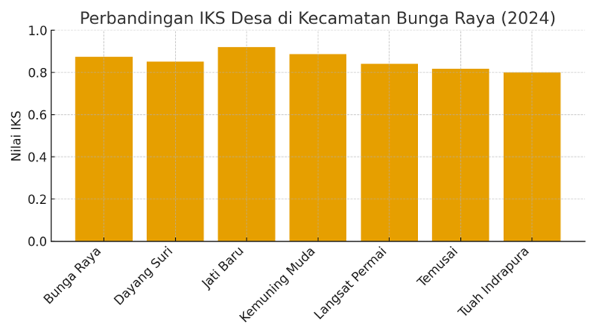
Figure 4.1 supports these findings by showing a comparison
Social Resilience Index (IKS) among villages in Bunga Raya District in 2024. The graph shows that the IKS values ​​for all villages ranged from 0.80 to 0.92, indicating a very good level of social resilience. Jati Baru Village had the highest score (0.92), followed by Kemuning Muda (0.8857), and Bunga Raya (0.8743). This condition illustrates that most villages have a strong social system, with the availability of basic services, adequate health and education facilities, and a high level of community participation in social activities.
The small differences between IKS scores indicate relatively low social disparities between villages in Bunga Raya District, indicating a fairly even distribution of social development. This reinforces previous analysis that improving community social quality is a crucial foundation for strengthening the economic and environmental dimensions of villages, in accordance with the principles of sustainable development within the Village Development Index (IDM) framework.
- Analysis of the Economic Resilience Index (IKE)
Figure 4.2 Summary of Socio-Economic Indicator Scores (2024)
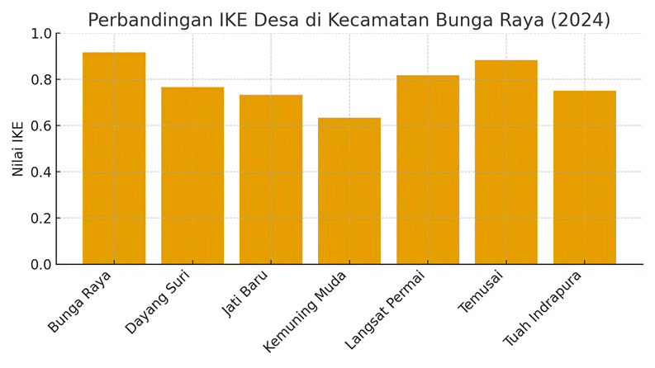
Figure 4.2 shows the distribution of the Economic Resilience Index (IKE)
Eight villages in Bunga Raya District, based on 2024 IDM data. Overall, the graph shows that all villages have relatively high IKE scores (ranging from 0.63 to 0.92), indicating good local economic capacity and community resilience in maintaining livelihoods. Bunga Raya Village ranks highest with a score of 0.9167, indicating strong economic sector dominance, primarily due to infrastructure support, market access, and the active role of village economic institutions (BUMDes). This is in line with its status as the center of sub-district economic activity.
Temusai Village ranked second (0.8833), showing a significant improvement compared to the 2022 measurement. This is believed to be influenced by increased access to microfinance institutions and optimization of the inland fisheries and local trade sectors. Langsat Permai Village (0.8167) also demonstrated high performance thanks to stable economic activity and effective agricultural management. Conversely, Kemuning Muda Village (0.6333) remains at the bottom of the economic resilience rankings. This score indicates limitations in business diversification and access to markets and financing institutions.
The differences between villages in this graph reflect the varying levels of adaptability and economic innovation among rural communities. Villages with high IKE scores have generally been able to capitalize on local potential through diverse production systems supported by adequate economic infrastructure. Meanwhile, villages with lower IKE scores require support from village economic development policies, particularly in terms of improving road infrastructure, developing village markets, and strengthening community economic institutions.
Overall, the results depicted in Figure 4.2 confirm that the economic resilience of villages in Bunga Raya District has experienced a positive increase compared to the previous year, but there are still gaps between regions that need to be addressed through more equitable development interventions oriented towards strengthening local economic capacity.
- Environmental Resilience Index (IKL) Analysis
Figure 4.3 Environmental Resilience Index (IKL) in 2024
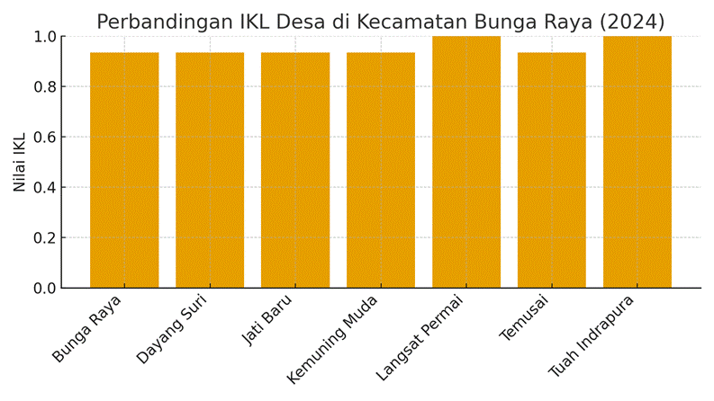
Figure 4.3 shows the Environmental Resilience Index (IKL) value
For eight villages in Bunga Raya District, based on 2024 HDI data, all villages showed high and relatively even IKL values, ranging from 0.93 to 1.00. This indicates that each village has a good level of awareness and adaptive capacity to environmental risks and natural disasters that have the potential to disrupt the sustainability of community socio-economic activities.
Langsat Permai and Tuah Indrapura villages scored the highest (1.00), indicating excellent environmental resilience. This indicates that both villages have effective environmental management systems, including wetland conservation, waste management, and disaster preparedness. Furthermore, these results reflect the village government's success in implementing environmentally conscious development policies and active community participation in inland water ecosystem conservation activities.
Meanwhile, other villages such as Bunga Raya, Dayang Suri, Jati Baru, Kemuning Muda, Langsat Permai, and Temusai continue to show high IKL scores (≥0.93), indicating stable and controlled environmental conditions. The equality of scores shown in this graph indicates that, in general, there are no significant gaps between villages in environmental dimensions. Therefore, Bunga Raya District as a whole can be categorized as an area with high environmental resilience, where aspects of conservation, preparedness, and disaster mitigation are well-functioning.
These findings reinforce the argument that successful environmental development at the village level is closely linked to collaboration between communities, village governments, and other local institutions in maintaining the quality of natural resources and reducing the risk of environmental damage. This aligns with the Sustainable Development Goals (SDGs), particularly points 13 (Addressing Climate Change) and 15 (Maintaining Terrestrial Ecosystems).

CONCLUSION
Based on the analysis of the 2024 Village Development Index (IDM) data for eight villages in Bunga Raya District, Siak Regency, it can be concluded that all villages have generally achieved "Independent Village" status, with an IDM score above 0.8. This achievement indicates that village development in the region has moved toward a sustainable balance between social, economic, and environmental dimensions.
From the results of measurements of the three main dimensions of the IDM, it is clear that the social dimension (IKS) has a relatively high and evenly distributed value across all villages, indicating strong community participation, the availability of good basic services, and solid social capacity. The economic dimension (IKE) shows greater variation between villages, with the highest value being in Bunga Raya Village (0.9167), followed by Temusai (0.8833) and Langsat Permai (0.8167). This indicates differences in the level of access to markets, financial institutions, and local economic infrastructure. Meanwhile, the environmental dimension (IKL) shows a very high score (0.93–1.00) and is relatively uniform across villages, reflecting ecological awareness and good environmental management.
In aggregate, the high HDI scores across all villages demonstrate the successful implementation of data-driven development policies driven by the Ministry of Villages, Development of Disadvantaged Regions, and Transmigration (Kemendes PDTT). These findings also demonstrate that development in Bunga Raya District aligns with the principles of the Village Sustainable Development Goals (SDGs), particularly those aimed at improving welfare, reducing inequality, and preserving the environment.
Addition: We are grateful for those and/or institutions that support research.

REFERENCES
Akbar, RA, Fauzan, M., Arsyad, AAJ, Barki, K. and Alamsyah. (2023), “Implementation of the Community Empowerment Approach to Improve the Quality of Life of Communities Through Regional Potential-Based Economic Development”, Journal of Scientech Research and Development, Vol. 5 No. 1, pp. 65–76, doi: 10.56670/jsrd.v5i1.95.
Arina, AIS, Masinambow, VAJ and Walewangko, EN (2021), “The Effect of Village Funds and Village Fund Allocation on the Village Development Index in Southeast Minahasa Regency”, Journal of Regional Economic and Financial Development, Vol. 22 No. 3, pp. 22–41.
Christianingrum, R. (2022), “Evaluation of Village Funds Seen from the Relationship Between Village Fund Ceilings and the Village Development Index”, Journal of Budget: Issues and Problems of State Finance, Vol. 5 No. 1, pp. 100–113, doi: 10.22212/jbudget.v5i1.52.
Depari, ET (2024), “Sustainable Development: Integration of Economic, Social, and Environmental Issues”, Circle Archive, Vol. 1 No. 5, pp. 1–13.
Hildayanti, A. and Machrizzandi, MS (2022), “Village Potential and Assets as Provisions for Improving the Quality of Development in Ratte Village, Tutar District”, Journal Peqguruang: Conference Series, Vol. 4 No. 2, p. 949, doi: 10.35329/jp.v4i2.3760.
Kayupa, OO, Guampe, F., Hengkeng, J. and Balo, MJ (2025), “Challenges and Opportunities in Implementing Participatory Village Development Planning in Indonesia”, Management and Organization Studies, Vol. 6 No. 1, pp. 187–199, doi: 10.35912/simo.v6i1.3483.
Kurniawati, E., Ibrahim and Nurhayati. (2025), “Quantitative Analysis of Environmentally Based Village Development Against the Village Development Index in West Lombok Regency”, Jurnal Humanitas, pp. 279–295.
Muhtarom, Kusuma, N. and Purwanti, E. (2018), “Analysis of the Village Development Index to Determine the Pattern of Village Development in Gadingrejo District, Pringsewu Regency”, Development Innovation: Research and Development Journal, Vol. 6 No. 02, pp. 179–190, doi: 10.35450/jip.v6i02.96.
Nabilla, LM, Putra, RM, and Efriyeldi. (2022), “Sustainable Mangrove Ecosystem Management Strategy in Buruk Bakul Village, Bukit Batu District, Bengkalis Regency, Riau Province”, Braz Dent J., Vol. 33 No. 1, pp. 1–12.
Nusantara, AB, Ramadhan, M., Bhakti, MTP, Assayuti, MJ, Zulfa, AA, Seran, GG and Aprilliayani, NV (2024), “Village-Owned Enterprises (BUMDes) Governance in Cigombong Village”, Karimah Tauhid, Vol. 3 No. 8, pp. 9000–9007, doi: 10.30997/karimahtauhid.v3i8.14785.
Ristanto, I., Devi, RH, Firdausi, AA, Teknik, F., Studi, P., Sipil, T., Veteran, U., et al. (2024), “ANALYSIS OF VILLAGE INFRASTRUCTURE ASSESSMENT RELATIONSHIP BASED ON VILLAGE DEVELOPMENT INDEX (IDM) VILLAGE SYNTAX CONTRAST HELMERT METHOD Article submitted: February 17, 2024 Revised: May 28, 2024 Accepted: June 11, 2024 Analysis of Infrastructure Assessment Relationship Des”, No. Idm, pp. 57–68.
Sibuea, SAN, Gai, AM, Poerwati, T. and Nirarta Samadhi, T. (2024), “Analysis of Priority Factors Influencing the Determination of Independent Village Status in Oro-Oro Ombo Village, Batu District, Batu City”, Urban Planning, Spatial, Culture, Landscape, Environment and Social Studies, Vol. 1 No. 1, pp. 12–23, doi: 10.36040/upscales.v1i1.10035.
Sihombing, PR, Arsani, AM, Angraini, W. and Pratiko, W. (2022), “Implementation of the SEM Model on the Relationship between HDI, IPD, and IDM”, Bayesian Journal: Scientific Journal of Statistics and Econometrics, Vol. 2 No. 2, pp. 107–115, doi: 10.46306/bay.v2i2.33.
Sutopo, DS (2024), “Towards a Welfare Village: Empowering Rural Development Through Participatory Spatial Planning Based on Village Potential”, Jurnal Education and Development, Vol. 12 No. 2, pp. 274–280.
Tajuddin, Anto, LO, Arifuddin, Ernawati and Wa Ode Rachmasari Ariani. (2025), “Technical Guidance for Improving the Status of Underdeveloped Villages to Developing Villages in Tinanggea District, Southeast Sulawesi Province”, Vol. 5 No. 1, pp. 63–70, doi: 10.54259/pakmas.v5i1.3218.

_________________________

About the Authors

Provide information about the Author(s), which consists of academic qualification, area of ​​specialization, and publication.

