LPJ

The Role Of Investigators In The Application Of Restorative Justice And Rehabilitation To Victims Of Drug Abuse In The Belawan Port Police

Mangatur Sirait¹ Kusbianto², Ariman Sitompul³*
Magister Hukum, Universitas Dharmawangsa, Medan, Indonesia.

Abstract
This study aims to determine the application of restorative justice and rehabilitation in the case of narcotics crime in legislation, the role of investigators in implementing restorative justice and rehabilitation in the Belawan jurisdiction, as well as the obstacles faced by investigators in implementing restorative justice and rehabilitation in the region. The research method used in this study is empirical juridical research that combines elements of law and scientific method. This study uses a qualitative approach with data collection techniques through interviews and document studies. The data sources consist of primary data obtained through observation, interviews, and questionnaires, as well as secondary data derived from primary and secondary legal materials. Data analysis is done descriptively by grouping, interpreting, and summarizing the data obtained. Investigators have an important role in handling cases of victims of drug abuse, including in the investigation, investigation, and rehabilitation. The implementation of restorative justice and rehabilitation at the Belawan Port Police Station has been carried out, but there are still obstacles such as lack of knowledge and skills of investigators, lack of support and facilities, and lack of community involvement. Increased training for investigators and stronger cooperation with communities and rehabilitation institutions are needed to improve the effectiveness of Drug Abuse Prevention.

Keywords: Drug abuse, investigator, Restorative Justice and Rehabilitation

1. INTRODUCTION
Narcotics cases are cases that are not only faced by the Indonesian nation, but also have become international cases and become Extraordinary crimes. Narcotics cases are of concern to all countries in the world, because the abuse of narcotics can damage one generation of a country.
Indonesia is one of the countries with a fairly high level of narcotics consumption in the world. Based on data from the National Narcotics Agency (BNN), in 2021 there were around 3,662,646 narcotics users in Indonesia. Ironically, drug abuse is prevalent among the younger generation. Based on data from kominfo 2021, it explains that drug use is among young people aged 15-35 years with a percentage of 82.4% as users, while 47.1% act as dealers, and 31.4% as couriers. While the most widely used types of drugs in Indonesia according to the Indonesia Drugs Report 2022 are marijuana 41.4%, methamphetamine 25.7%, nipam 11.8% and dextro 6.4%.
In anticipating and narrowing the space for narcotics abuse, the Indonesian government formed a Non-ministerial government agency (LPNK), namely the National Narcotics Agency (BNN). This institution was established to carry out government tasks in the field of prevention, eradication of abuse and illicit circulation of narcotics, precursors and other addictive substances except addictive substances for tobacco and alcohol. Prevention and eradication of narcotics abuse is not only carried out by BNN alone, but also in coordination with the police. In this case, the police also contribute to the prevention and eradication of narcotics abuse that enters the community disease.
Coordination between BNN and the police has reaped many successes in uncovering cases of narcotics abuse. Throughout 2021 alone, BNN and the police managed to uncover 28,938 cases of narcotics crimes with a total of 53,405 suspects. North Sumatra province became the largest contributor to narcotics crime cases as many as 7,353 cases. In fact, if narrowed down, throughout 2021 the Belawan Police Region Drug Investigation Unit handled 265 cases.
The application of criminal law in the case of narcotics crime has tended to prioritize aspects of punishment or retribution. The punishment applied to the perpetrators of narcotic crimes is imprisonment or even the death penalty. However, a purely punitive approach does not always provide an effective solution to the problem of drug crime. Often we think that when dealing with narcotics cases, the criminal justice system becomes a legal tool that can be used in tackling narcotics cases. However, the criminal justice system is different from Criminal Procedure Law. Andi Hamzah argues that the scope of Criminal Procedure Law and the criminal justice system are very different. Criminal Procedure Law is only concerned with its legal aspects, while the criminal justice system encompasses much more than that, it even includes matters that are not legal.
One of them is related to the implementation of inmate development carried out by the Correctional Institution (lapas) as one of the sub-systems of criminal justice. In Law No. 12 of 1995 on Penitentiary, it is stated that the penitentiary system is organized in order to form Penitentiary inmates in order to become fully human, realize mistakes, improve themselves, and not repeat crimes so that they can be accepted again by the community environment.
In its development, the coaching carried out is not optimal because of the complex problems that occur in prisons. One of them is the problem of excess capacity (Overcrowding). Based on data from the Directorate General of Corrections of the Ministry of Law and Human Rights of the Republic of Indonesia, as of March 31, 2020, the number of prisoners and inmates in all prisons and detention centers in Indonesia was 270,351 people. This number far exceeds the ideal capacity that can be accommodated by prisons and detention centers as a whole, which is only 131,931 people.
Efforts to overcome the problem of Overcrowding not only stop at the affairs of the addition of the capacity of Prisons and detention centers (Rutan). But also at least it can start from the beginning of law enforcement with the application of Restorative Justice approach to narcotics cases. This approach primarily targets those who are addicts, abusers or victims of abuse. Imposing criminal sanctions on addicts, abusers or victims of abuse according to the authors is not the right step.
Restorative justice and rehabilitation are two concepts that can be an alternative approach in handling narcotics criminal cases. The restorative justice approach aims to restore the balance and damaged relationship between the perpetrator and the victim or the community. While rehabilitation aims to return perpetrators of criminal acts into society by helping them overcome the problem of narcotic dependence.
Restorative Justice is a shift in punishment in the criminal justice system that prioritizes justice for victims and perpetrators of criminal acts in addition to alternative punishments such as social work and others. Bagir Manan suggested that the substance of restorative justice which contains principles such as: building joint participation between perpetrators, victims, and community groups to resolve an event or criminal act; placing perpetrators, victims, and the community as “Stakeholders” who work together and directly try to find solutions that are considered fair to all parties (win-win solutions).
At the Belawan Port Police Station, Drug Abuse is one of the main problems that needs to be addressed. Belawan Port Police is a strategic area because there is an international port that is the entrance for goods from abroad. Because of this, many cases of drug abuse occur in this region. When viewed from the recapitulation data of drug crimes at the Belawan Port Police, drug crimes tend to increase in the period 2018-2022. The increase in drug crime can be seen from the following table:
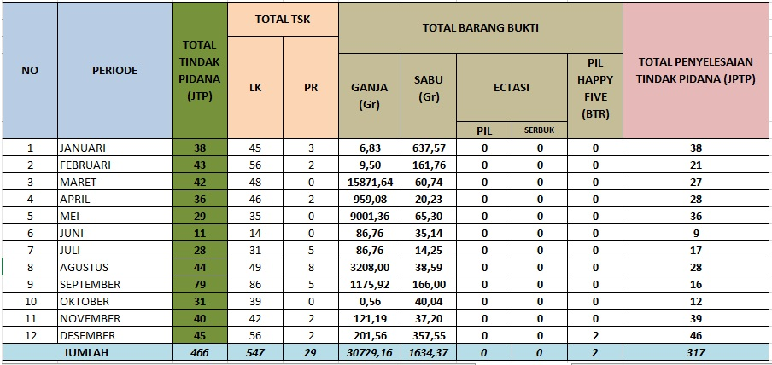
Source: Belawan Port Police Recapitulation Data For Drug Crimes In 2018 Belawan Port Police Station
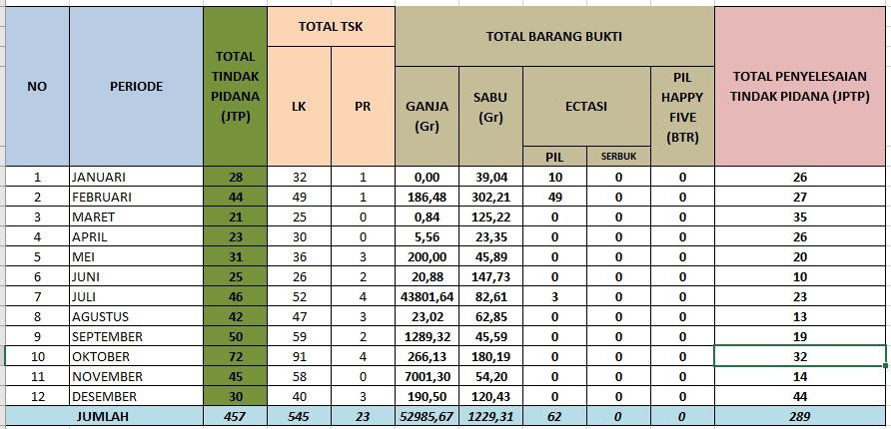
Source: Belawan Port Police Recapitulation Data For Drug Crimes In 2019 Belawan Port Police Station
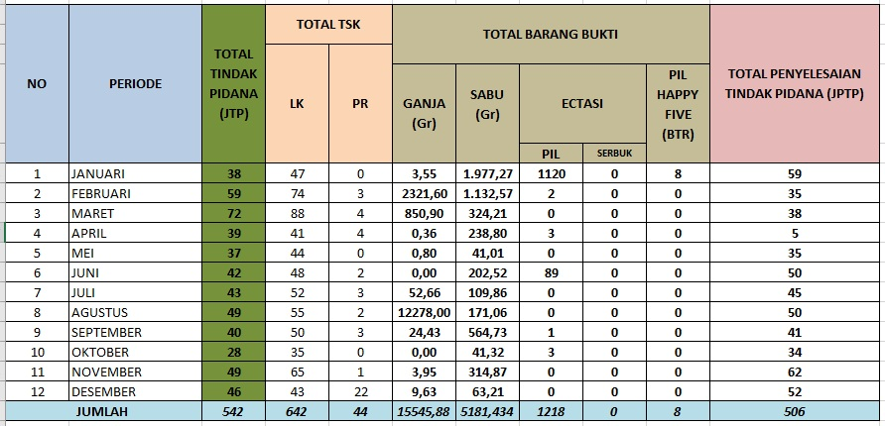
Source: Belawan Port Police Data Recapitulation Data For Drug Crimes In 2020 Belawan Port Police Station
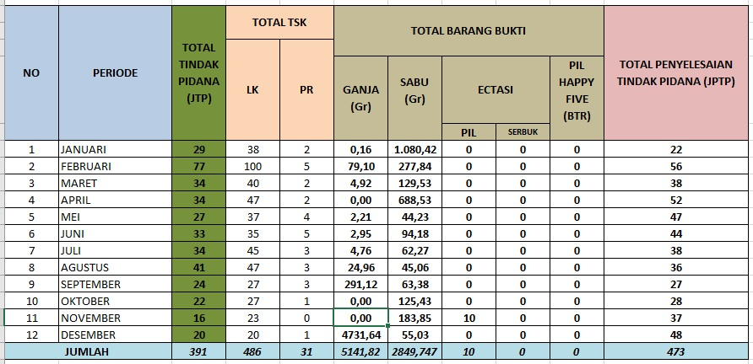
Source: Belawan Port Police Recapitulation Data For Narcotics Crimes In 2021 Belawan Port Police Station
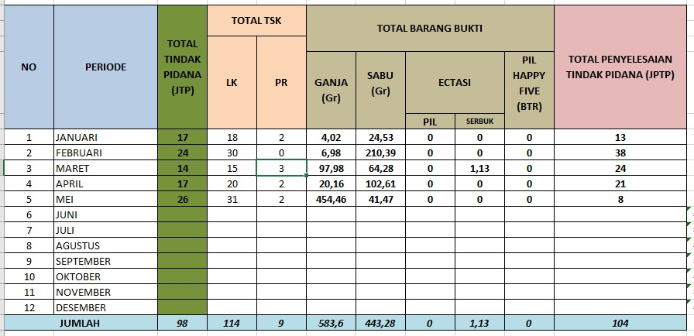
Source: Belawan Port Police Recapitulation Data For Narcotics Crimes In 2022 Belawan Port Police Station
Based on the recapitulation data of drug crimes in the ranks of the Belawan Port Police, there is a tendency for an increase in narcotics crimes from 2018 to May 2022. In 2018, the number of narcotics crimes was 466 and increased to 542 in 2020. Although in 2021 the number of narcotics crimes decreased, in 2022 from January to May, the number of narcotics crimes again increased to 98 cases.
This can also be seen from the number of suspects arrested, where in 2018 there were 547 male suspects and 29 female suspects, and increased to 642 male suspects and 44 female suspects in 2020. In 2021, the number of male suspects decreased but the number of female suspects increased. While in 2022 from January to May, the number of male suspects increased again. The settlement of criminal offenses is also a concern, where in 2018 a total of 317 cases were successfully resolved and in 2020 there was an increase in the number of case settlements to 506. However, in 2019 and 2021 the number of case settlements decreased. In 2022 from January to May, the number of case settlements was 104, which is an increase compared to the previous year.
Year 2022  (Januari-Juli) |  | Year 2023  (Januari-Maret)
Total LP | LP Pengguna (TAT) | Total LP | LP Pengguna (TAT)
302 | 51 | 65 | 13
Source: Polres Pelabuhan Belawan Police Report Data Polres Pelabuhan Belawan Year 2022-2023
Based on the data above, in 2022 there were a total of 302 police reports related to narcotics crimes and of these, 51 reports were selected to be accommodated through the restorative justice approach. Meanwhile, in 2023, the number of police reports decreased to 65, and 13 reports were selected to apply the restorative justice approach. Despite the decrease in the number of police reports in 2023, the number of reports selected for restorative justice is still relatively stable with the same percentage in 2022 and 2023 at around 17%. This shows that the use of restorative justice in cases of narcotics abuse is still being carried out and has the support of law enforcement authorities.
Polres Pelabuhan Belawan is one of the police in Indonesia that has implemented a restorative justice and rehabilitation approach in handling narcotics criminal cases, especially for addicts and victims of drug abuse. This is in accordance with the regulation of the Indonesian National Police Number 8 of 2021 on handling criminal acts based on Restorative Justice which requires that criminal acts be handled based on restorative justice. In Article 6 and Article 7 of this regulation discusses the formal and special requirements in the handling of criminal acts which include peace between the perpetrator and the victim as well as the fulfillment of the rights of the victim and the responsibility of the perpetrator. However, Article 7 states that there are special requirements for drug crimes.
Article 9 then sets out specific requirements for drug offenses, which include drug addicts and victims of drug abuse who are drug or urine test positive, but are not involved in a network of drug offenses, dealers, and/or bookmakers. The perpetrator must also have been assessed by an integrated assessment team and be willing to cooperate with police investigators to conduct further investigations. In the context of the treatment of drug addicts, there is the concept of restorative justice and rehabilitation, which is the basis of the law in Article 9. Restorative justice focuses on restoring the relationship between perpetrators and victims and the recovery of affected communities. While rehabilitation aims to provide treatment and care for drug addicts in order to recover and return to being productive members of society. This is in accordance with the Supreme Court Circular No. 04 of 2010 on the placement of abuse, abuse victims and drug addicts into medical rehabilitation and social rehabilitation institutions and the Supreme Court Circular No. 03 of 2011 on the placement of victims of narcotics abuse in Medical Rehabilitation and social rehabilitation institutions.
In this regard, the specific requirements set forth in Article 9 indicate that the recovery and rehabilitation of drug addicts is a priority in the treatment of drug crimes. Through the assessment by the Integrated Assessment Team, the perpetrator can be identified the condition and the need for proper rehabilitation. In addition, the perpetrator must also be willing to cooperate with police investigators in conducting further investigations, which can help in preventing the recurrence of acts of drug abuse in the future. Restorative justice and rehabilitation are directed at efforts to repair and restore drug abusers into society. The specific requirements set out in Article 9 are expected to help drug addicts to get proper treatment and recovery, so that they can return to being productive members of society. However, the application of this approach cannot be done on its own. In its application, the Belawan Port Police requires the role of a strong and trained investigator to carry out his duties properly.
The application of restorative justice and rehabilitation to victims of drug abuse in the Belawan Port Police, the role of investigators becomes very important. The investigator must have sufficient knowledge and skills to identify victims of drug abuse and understand their condition. In addition, the investigator must also be able to direct the victim into a rehabilitation program that suits their needs. To better understand the role of investigators in the application of restorative justice and rehabilitation to victims of drug abuse, a case study was conducted at the Belawan Port Police Station. Therefore, it is interesting to investigate further on the application of restorative justice and rehabilitation in narcotics cases in Indonesia at the investigation level based on the provisions set by the Supreme Court and other relevant agencies above, especially in the field of combating and preventing narcotics crimes in Indonesia. So based on the background exposure above, the researchers are interested in discussing thoroughly about, “the role of investigators in the application of Restorative Justice and rehabilitation of victims of Drug Abuse (Case Study in Belawan Port Police Station)”.

2. RESEARCH METHOD
This type of research is empirical juridical research. Empirical juridical research is a research method that combines elements of law (juridical) with the scientific method (empirical) in conducting research. Empirical juridical research aims to answer a legal problem by collecting empirical data, such as primary and secondary data, and analyzing them quantitatively and qualitatively. In this empirical juridical Research, researchers will collect data through interview techniques and document studies, then analyze the data using qualitative analysis methods. Qualitative research is a research procedure that produces descriptive data, namely what is stated by the informant in writing or orally, and real behavior. The research method used in this study is to observe, learn, and understand the situation and activities that occur in the field through interviews with resource persons.

3. RESULT AND ANALYSIS
3.1. The role of investigators in the application of Restorative Justice to victims of Drug Abuse
Law enforcement using the restorative justice approach has become increasingly popular in Indonesia in recent years. Restorative justice is an approach that focuses on the recovery of victims and the relationship between perpetrators and victims after a criminal offense. This approach is different from the approach of retributive justice which focuses more on the punishment of perpetrators of criminal acts. Restorative justice prioritizes restoration and reconciliation, while retributive justice prioritizes conviction and punishment
According to Article 14 of Police Regulation Number 8 of 2021, in general, the role of police investigators in implementing law enforcement with restorative justice includes:
- Inviting the parties to the conflict
- Facilitate or mediate between parties;
- Make a report on the results of mediation; and
- Record in the restorative justice register of problem solving and termination of tipiring investigations.
There are 3 (three) important roles of Belawan Port Police investigators in implementing law enforcement with restorative justice on victims of drug abuse, namely peace efforts outside the court, providing opportunities for perpetrators of criminal acts to be responsible for making amends, and solving criminal law problems that occur between perpetrators of criminal acts and victims of criminal acts.
- Out-of-court peace efforts by perpetrators of criminal acts against victims of criminal acts.
- Provide opportunities for perpetrators of criminal acts to be responsible for making amends by compensating for losses due to criminal acts committed.
- Resolve criminal law issues that occur between the perpetrator of the crime and the victim of the crime if Agreement and agreement is reached between the parties.
Efforts for peace outside the court by perpetrators of criminal acts against victims of criminal acts is one form of application of restorative justice in law enforcement. This effort aims to assist victims and perpetrators of criminal acts in restoring relationships damaged by criminal acts committed. Settlement through out-of-court peace efforts can also reduce the workload of courts that are already congested with various criminal cases.
The role of the Belawan Port Police investigator in peace efforts outside the court is as a mediator between victims and perpetrators of criminal acts. Investigators will facilitate meetings between victims and perpetrators of criminal acts to discuss ways of settlement desired by both parties. During the meeting, investigators will invite victims and perpetrators of criminal acts to open up and listen to each other. In the context of drug abuse, out-of-court peace efforts can be made by holding the perpetrator of the crime to account for his actions and admitting his guilt to the victim. The perpetrator of the crime can also be asked to provide an apology to the victim and assist the victim in recovering from the impact caused by the criminal act he committed. In this case, the investigator will act as a mediator to help the victim and the perpetrator of the crime reach a mutually beneficial agreement.
Out-of-court peace efforts not only benefit victims and perpetrators of criminal acts, but also benefit society and the criminal justice system. In this regard, the use of out-of-court peace efforts can help reduce court workload, save court costs, and increase public confidence in the criminal justice system. However, there are some weaknesses in the application of out-of-court peace efforts. One of them is the potential for manipulation and pressure on victims to accept offers of peace from perpetrators of criminal acts. Therefore, strict supervision and control of the police and other institutions in the process of mediation between victims and perpetrators of criminal acts is necessary.
Provide opportunities for perpetrators of criminal acts to be responsible for making amends by compensating for losses due to criminal acts committed. It is also part of the restorative justice approach that aims to restore victims and improve the relationship between victims and perpetrators of criminal acts. In the context of drug abuse, the perpetrator of a criminal act may be required to pay compensation to the victim for losses that have been suffered as a result of the criminal act committed by the perpetrator. The losses in question can be in the form of medical expenses, property damage, or even non-material losses such as trauma or difficulty in establishing social relationships. Belawan Port Police investigators will act as mediators in the negotiation process between victims and perpetrators of criminal acts. The investigator will help establish the amount of damages to be paid by the perpetrator of the crime and ensure that the agreement is fair to both parties. In this case, the perpetrator of the crime can make a positive contribution to the victim and society by paying compensation for the criminal act committed. However, there are some weaknesses in the application of this second point. One of them is the possibility that the perpetrator of the crime is not able to pay the compensation that has been set, either because of financial limitations or because he does not want to be responsible for his actions. Therefore, it is necessary to carry out strict supervision and control of the police and other institutions in the negotiation process between victims and perpetrators of criminal acts.
The settlement of criminal law issues that occur between perpetrators of criminal acts and victims of criminal acts occurs when Agreement and agreement is reached between the parties. This is also part of the restorative justice approach which aims to improve the relationship between victims and perpetrators of criminal acts and restore the situation as before the occurrence of criminal acts. In the context of drug abuse, the resolution of Criminal Law problems can be done by reaching an agreement between the victim and the perpetrator of the crime. The agreement may take the form of an apology, payment of damages, or any other action deemed appropriate by both parties. In this case, the Belawan Port Police investigator will act as a mediator and help the parties reach a mutually beneficial agreement. In the process of resolving criminal law issues, the Belawan Port Police investigator must ensure that the agreement reached does not violate the law and does not harm third parties. In addition, the investigator must also ensure that the victim does not feel compelled or forced to accept the agreement. However, there are some weaknesses in the application of this third point. One of them is the possibility that the agreement reached is unfair to the victim or perpetrator of the criminal offense. Therefore, it is necessary to carry out strict supervision and control of the police and other institutions in the process of mediation and negotiation between victims and perpetrators of criminal acts.

3.2. The role of investigators in rehabilitation of victims of Drug Abuse
Article 103 paragraph (1), (2), and (3) of the Narcotics Law describes two types of narcotics addicts, narcotics addicts who are proven to have committed narcotics crimes and narcotics addicts who are not proven to have committed narcotics crimes. Article 103 of the Narcotics Law explains that drug addicts who are proven to have committed narcotics crimes will be sentenced or sentenced by the judge, while drug addicts who are not proven to have committed narcotics crimes will not be sentenced or sentenced by the judge. The judge's ruling is intended to emphasize that even if drug addicts are not found guilty of drug crimes, they still have to undergo treatment and treatment.
A circular from the Supreme Court on the placement of victims of narcotic abuse in Medical Rehabilitation and social rehabilitation institutions states that under Article 103 of law no. 35 of 2009 and Article 13 paragraph (2) of Government Regulation No. 25 of 2011, the order to carry out medical and social rehabilitation can only be carried out on the basis of a court decision for addicts who are found guilty of committing narcotic crimes, or the establishment of a court for drug addicts who are not proven guilty and suspects who are still under investigation or prosecution. In addition, the Government of the Republic of Indonesia Regulation No. 25 of 2011 on the implementation of mandatory reporting of narcotics addicts Article 13 paragraph (2) also confirms that the obligation to undergo medical and/or social rehabilitation applies to narcotics addicts who are ordered based on a court decision if proven guilty of committing a narcotics crime, or a court determination if not proven guilty of committing a narcotics crime.
In Circular No. 3 of 2011 concerning the placement of victims of narcotics abuse in Medical Rehabilitation and social rehabilitation institutions, it is stated that Article 103 of law no.35 of 2009 and Article 13 paragraph (2) of Government Regulation No. 25 of 2011 states that medical and social rehabilitation can only be ordered by the court, both for addicts who are found guilty of drug crimes and for drug addicts who are not proven guilty and suspects who are still in the process of Investigation or prosecution. Judges must pay attention to and refer to the circular of the Supreme Court (SEMA) number 4 of 2010 concerning the placement of abusers, victims of abuse, and Narcotics addicts in Medical Rehabilitation and social rehabilitation institutions related to convictions stipulated in Article 103 of Law Number 35 of 2009 concerning narcotics. Therefore, the stage of rehabilitation can only be determined by a court decision or determination.
Drug addicts must undergo medical and social rehabilitation in accordance with Article 127 (1), which takes into account the elements of criminal liability, namely the actus reus and mens rea. Article 127, Article 54, and Article 103 of the narcotics law state that narcotics users can undergo medical and social rehabilitation. Based on SEMA RI No. 4 of 2010 and Article 103, judges are authorized to place narcotics addicts in rehabilitation institutions. Rehabilitation as a recovery process has its advantages and disadvantages. The advantages of rehabilitation include a place for treatment, breaking the chain of drug trafficking, a place of isolation from environmental influences, as well as a humanistic form of crime. However, the shortcomings of rehabilitation include being a refuge for drug mafias, the absence of standard criteria for the length of rehabilitation, the still high incidence of relapse, and not dealing with the root of the problem. Therefore, the determination of the stage of rehabilitation should be carried out carefully to ensure effective recovery for those who are completely dependent on drugs.
In the implementation of rehabilitation, Article 97 paragraph (2) of the Criminal Procedure Code stipulates that "rehabilitation must be given and included in the court decision as mentioned in Paragraph (1)."This stage of rehabilitation can be established through a court decision or determination. Based on the regulation of the head of the National Narcotics Agency Number 11 of 2014 on procedures for handling suspects and/or defendants of narcotics addicts and victims of narcotics abuse into rehabilitation institutions, Article 3 Paragraph (1) confirms that people caught in narcotics abuse and victims of narcotics abuse who are without rights and violate the law, which are currently being processed in the stages of investigation, prosecution, and trial in court, must be given treatment and rehabilitation in rehabilitation institutions.
The explanation of medical rehabilitation is contained in Article 1 Number 16 of the Narcotics Law, determining that: “a process of integrated recovery activities to free addicts from narcotic dependence”. An explanation of social rehabilitation is found in Article 1 Number 17 of the Narcotics Law, determining that: “a process of integrated recovery activities, both physical, mental and social, so that former narcotics addicts can return to carry out social functions in people's lives”. Rehabilitation is one form of sanctions for the perpetrators and victims of drug abuse. Jonkers explains that criminal sanctions are used to crack down on crimes committed, while sanctions actions aim at social repair and rehabilitation.
In the Narcotics Law, one of the sanctions applied is the sanction of action or maatregel in the form of rehabilitation. According to Sholehuddin, sanctions actions have the aim to protect the community and increase effectiveness in efforts to prevent and treat narcotics abuse. The concept of a double track system used in dealing with narcotics problems, in which action sanctions and criminal sanctions are applied in a balanced manner, is the basis for thinking in this regard.
The criminalization policy of the Narcotics Law seems inseparable from the purpose of the law, which has been contained in the consideration of the Narcotics Law, which has 6 items, namely:
- That to realize a prosperous, just and prosperous Indonesian society that is equitable materially and spiritually based on Pancasila and the Constitution of the Republic of Indonesia in 1945, the quality of human resources as one of the national development capital needs to be maintained and improved continuously, including the degree of Health;
- That to improve the health status of Indonesian human resources in order to realize the welfare of the people, it is necessary to make efforts to improve in the field of Medicine and health services, among others, by seeking the availability of certain types of narcotics that are needed as drugs and to prevent and eradicate the dangers of abuse and illicit circulation of;
- 3. That narcotics on the one hand is a drug or material that is useful in the field of medicine or health services and the development of Science and on the other hand can also cause dependence that is very harmful if misused or used without control and supervision of strict and careful;
- That importing, exporting, producing, planting, storing, distributing, and/or using narcotics without strict and thorough control and supervision and contrary to the laws and regulations is a narcotics crime because it is very harmful and is a very great danger to human life, society, nation, and state as well as the national security of Indonesia;
- That narcotics crime has been transnational committed using a high modus operandi, advanced technology, supported by a wide network of organizations, and has caused many victims, especially among the younger generation of the nation who greatly endanger the lives of the community, nation, and state so that Law No. 22 of 1997 on narcotics is no longer in accordance with the development of the situation and;
- That based on the considerations referred to in letter a, letter b, letter c, letter d, and letter e, it is necessary to form a law on narcotics.
Article 103 paragraph (1) and (2) of the Narcotics Law explains that the judge who examines the case of a narcotics addict can order the person concerned to undergo treatment and/or treatment through rehabilitation if the narcotics addict is found guilty of committing a narcotics crime, or if the narcotics addict is not found guilty of committing a Narcotics Crime. The period of treatment and / or treatment for narcotic addicts ordered by the judge is counted as the period of serving the sentence. Article 103 paragraph (1), (2), and (3) of the narcotics law regulates narcotics addicts who are proven to have committed narcotics crimes and narcotics addicts who are not proven to have committed narcotics crimes. The definition of a narcotics addict who is proven to have committed a criminal offense can be found in the explanation of Article 103 of the Narcotics Law which states that the judge's decision is a verdict (punishment) for the narcotics addict concerned. Meanwhile, drug addicts who are not proven to have committed a criminal offense are not sentenced to a verdict (punishment) by a judge, but are still obliged to undergo treatment and treatment. It aims to affirm that although it is not proven to have committed a narcotics crime, narcotics addicts must still undergo treatment and treatment.
The circular of the Supreme Court on the placement of victims of narcotic abuse within Medical Rehabilitation and social rehabilitation institutions, establishes that the order to carry out medical and social rehabilitation can only be carried out under Article 103 of law no. 35 of 2009 and Article 13 paragraph (2) of Government Regulation No. 25 of 2011. The articles state that an order to carry out medical and social rehabilitation can only be given if there is a court decision for addicts who are found guilty of committing narcotic crimes or a court determination for drug addicts who are not proven guilty and suspects who are still under investigation or prosecution. Nevertheless, referring to Article 9 of Police Regulation Number 8 of 2021, rehabilitation can be submitted by drug addicts and victims of drug abuse before a court decision. Article 9 of Police Regulation Number 8 of 2021 establishes special requirements for drug crimes based on restorative justice, which include certain conditions that must be met so that suspects can apply for rehabilitation. These requirements include, among others, that the perpetrator must be willing to cooperate with police investigators to conduct further investigations, have been assessed by an integrated assessment team, and not be involved in drug crime networks, dealers, and/or bookmakers.
The role of the investigator in rehabilitation in victims of drug abuse is very important, because the investigator has the task of conducting investigations, collecting evidence, and determining whether a person meets the requirements to apply for rehabilitation. In the context of Article 9, the investigator must cooperate with the perpetrator who is willing to carry out a follow-up investigation, so as to determine whether the perpetrator meets the requirements to participate in rehabilitation. In addition, an integrated assessment team carried out in accordance with the provisions of laws and regulations must involve investigators to provide input and advice on the condition of the perpetrators to be rehabilitated.

4. CONCLUSION
The role of investigators is very important in the application of restorative justice and rehabilitation to victims of drug abuse in the Belawan Port Police Station. To strengthen the efforts of restorative justice and rehabilitation, it is necessary to improve the quality and quantity of training and education for investigators in order to understand well the technical and process of implementing restorative justice and rehabilitation. In addition, cooperation with various related parties, such as communities and rehabilitation institutions, also needs to be improved to improve the effectiveness of restorative justice and rehabilitation efforts on drug abuse victims. Thus, it is hoped that an environment free from drug abuse and a healthier and more prosperous society can be created.

REFERENCE

Adi Sujanto, Pencerahan Dibalik Penjara dari Sangkar Menuju Sanggar Untuk Menjadi Manusia Mandiri, Jakarta: Teraju, 2008.
Andi Hamzah, Hukum Acara Pidana Indonesia, Jakarta: Sinar Grafika, 2019.
Budi Sudarto, Peraturan-peraturan Penting Tentang Narkotika, Jakarta: Prenada, 2021.
D.P. Rahayu dan T.P. Susilowati, Implementasi Restorative Justice dalam Sistem Peradilan Pidana Indonesia, Jurnal Penelitian Hukum De Jure, Vol. 16, No. 1, 2016.
Dadang Hawari, Penyalahgunaan & Ketergantungan NAZA (Narkotika, Alkohol, & Zat Adiktif), Jakarta: Gaya Baru, 2006.
Data Rekapitulasi Tindak Pidana Narkoba Tahun 2021 Khusus Satnarkoba Polres Pelabuhan Belawan.
Devi Azwar Rizki, Penegakan Hukum Restoratif dalam Konteks Pidana Narkoba di Indonesia, Bandung: Refika Aditama, 2021.
Direktorat Jenderal Pemasyarakatan Kementerian Hukum dan Hak Asasi Manusia, Meretas Kebijakan Asimilasi Bagi Narapidana, diakses dari http://www.ditjenpas.go.id/meretas- kebijakan- asimilasi-bagi-narapidana, diakses pada 12 Desember 2022, pukul 18:00 WIB.
Dvannes, Restorative Justice Briefing Paper-2, Centre for Justice & Reconciliation, November 2008.
Guntari, S., Kusbianto, K., Zuliah, A., & Sitompul, A. (2024). Legal Regulations for Children Involved in Narcotics Crimes in Indonesia. SEIKAT: Jurnal Ilmu Sosial, Politik Dan Hukum, 3(3), 194–202. https://doi.org/10.55681/seikat.v3i3.1301
Haposan Sahala Raja Sinaga, Penerapan Restorative Justice dalam Perkara Narkotika di Indonesia, Jurnal Hukum Lex Generalis, Vol. 2 No. 7, Juli 2021.
Hari Sasangka, Narkotika dan Psikotropika dalam Hukum Pidana, Bandung: Mandar Maju, 2003.
Hendarawan Supratikno dkk, Strategi Rehabilitasi Penyalahguna Narkoba dalam Perspektif Kesehatan Masyarakat, Jurnal Kesehatan Masyarakat, Vol. 9, No. 1, 2014.
https://bnn.go.id/hindari-narkotika-cerdaskan-generasi-muda-bangsa/#:~:text= sesuai%20dengan%20data%20yang%20ada,adalah%20kelompok%20usia%20remaja%2Fmuda.&text=Berdasarkan%20data%20dari%20Indonesia%20Drugs,dan%20dextro%206%2C4%25, diakses pada tanggal 12 Desember 2022, pukul 12:59 wib.
https://puslitdatin.bnn.go.id/konten/unggahan/2022/07/IDR-2022.pdf, diakses pada tanggal 12 Desember 2022, pukul 13:39 WIB.
JJH Bruggink, Refleksi tentang Hukum, Alih Bahasa Arief Sidharta, Bandung: Citra Adity.
M. Saifuddin Azwar, Penegakan Hukum Restoratif di Indonesia: Telaah Yuridis dan Implementasinya di Lapangan, Jakarta: Kencana Prenada, 2021.
Mark M. Lanier dan Stuart Henry, Essential Criminology, Second Edition, Wastview, Colorado, USA, 2004, hal. 332 dan 407-408.
Mark Umbreit, Family Group Conferencing: Implications for Crime Victims, The Center for Restorative Justice, University of Minnesota, doj/ovc/publications/infores/restorative_justices/9523-family_group/family3.html., 2001.
Masyhuri Imron dkk, Survei Nasional Penyalahgunaan Narkoba Tahun 2021, Jakarta: Pusat Penelitian, Data, dan Informasi BNN, 2022.
Nasir Sitompul, M., & Sitompul, A. (2022). EXECUTION OF DEATH PENALTY IN NARCOTICS CRIME IN THE PERSPECTIVE OF NATIONAL LAW IN INDONESIA. International Asia Of Law and Money Laundering (IAML), 1(2), 107–112. https://doi.org/10.59712/iaml.v1i2.19
Pasal 15 huruf c Undang-Undang Nomor 2 Tahun 2002 tentang Kepolisian Negara Republik Indonesia.
Pasal 2 Peraturan Pemerintah Republik Indonesia Nomor 83 Tahun 2007 tentang Badan Narkotika Nasional, Badan Narkotika Provinsi, dan Badan Narkotika Kabupaten/Kota.
Pasal 70 huruf c Undang-Undang Nomor 35 Tahun 2009 tentang Narkotika.
R. Fitriani, Peran Polisi dalam Pelaksanaan Restorative Justice, Jurnal Hukum Respublica, Vol. 1, No.1, 2018.
Rizky Amaliah, Penegakan Hukum Restorative Justice dalam Penyelesaian Tindak Pidana Narkotika, Jurnal Hukum Noken, Vol. 3, No. 2, 2020.
Rocky Mabun, Restorative Justice Sebagai Sistem Pemidanaan di Mas Depan, http://forumduniahukumblogku.wordpress.com, diakses pada 08 Maret 2023, pukul 13.21 WIB.
Sitompul, A., & Sitompul, M. N. (2020, February). The Combination Of Money Laundering Crime With The Origin Of Narkotics Crime To Islamic Law. In Proceeding International Seminar of Islamic Studies (Vol. 1, No. 1,).
Sitompul, A., Gayo, S., & Mary, D. (2024). Mediation in the Settlement of Inheritance and Joint Property Matters in the Medan Religious Court. International Asia Of Law and Money Laundering (IAML), 3(2), 34–39. https://doi.org/10.59712/iaml.v3i2.85
Sthepanie Coward-Yaskiw, Restorative Justice: What Is It? Can It Work? What Do Women Think?, Horizons 15 Spring), http: web.infotrac.gale-group.com; Lihat : Mark M. Lanier dan Stuart Henry, Essential Criminology, Second Edition, Westview, Colorado, USA, 2004.
Susan C. Hall, Restorative Justice in the Islamic Penal Law. A Cintribution to the Global System, Duquesne University School of Law Research Paper, No. 2012.
Tony Marshall, Restorative Justice: An Overview, London: Home Office Research Development and Statistic Directorate, 1999, hal. 5, diakses dari website: http//www.restorativejustice.org., diakses pada tanggal 08 Maret 2023, pukul 10:23 WIB.
UNODC, Handbook on Restorative Justice Programmes. Criminal Justice Handbook Series, Vienna: UN New York, 2006.
Wright, 1991 hal. 117 diakses dari website http://www.restorativejustice.org pada tanggal 08 Maret 2023, pukul 11.13 WIB.

*Email/Corresponding Author: ariman.sitompul@dharmawangsa.ac.id

